Christopher Bazyani

CYB 552

Advanced Hacking Prevention

Assessing and Securing Systems on a Wide Area Network (WAN)

**Section 1: Hands-On Demonstration**

-O Detect operating system

-v Increased output verbosity (a greater level of detail)

Part 1: Scan the Wide Area Network

At the prompt, type nmap –O –v 100.16.16.50 and press Enter to use Nmap to detect the operating system (-O) of the TargetVulnerable01 machine (100.16.16.50) with increased output verbosity (-v).

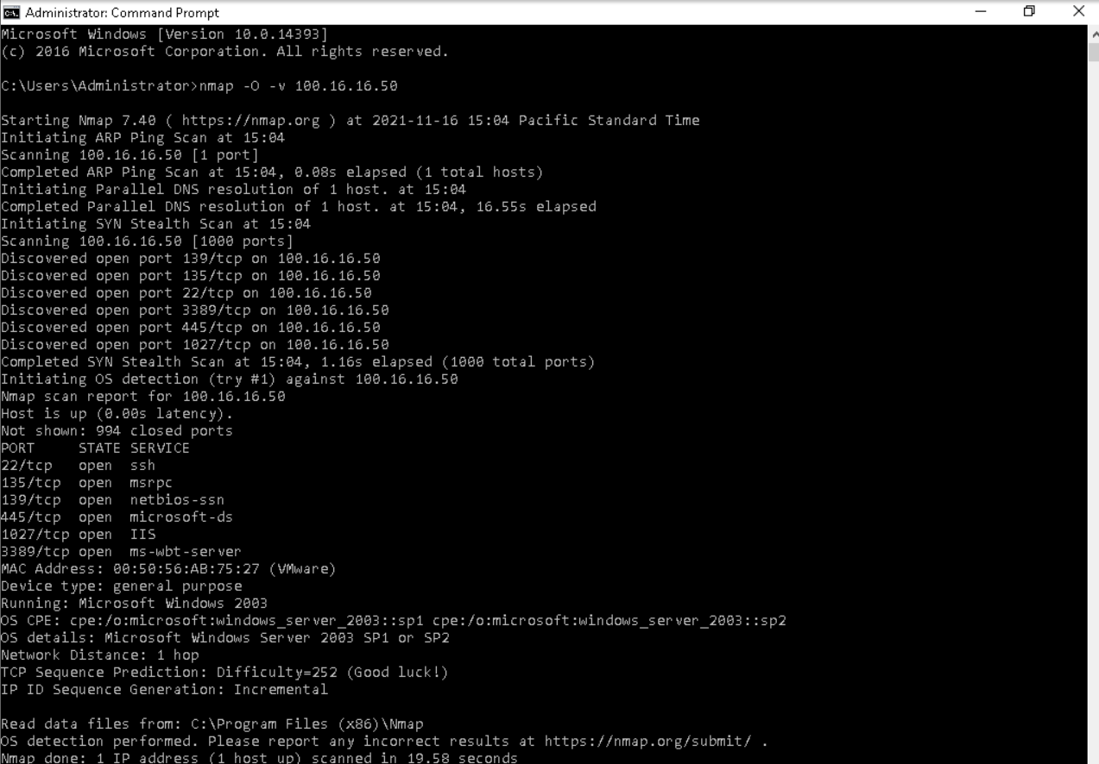

At the command prompt, type nmap --script=smb-vuln-ms08-067 -p445 100.16.16.50 and press Enter to run a script (--script) checking port 445 (-p445) on the TargetVulnerable01 machine (100.16.16.50) for a SMB vulnerability (smb-vuln), specifically the MS08-067 exploit (-ms08-067)

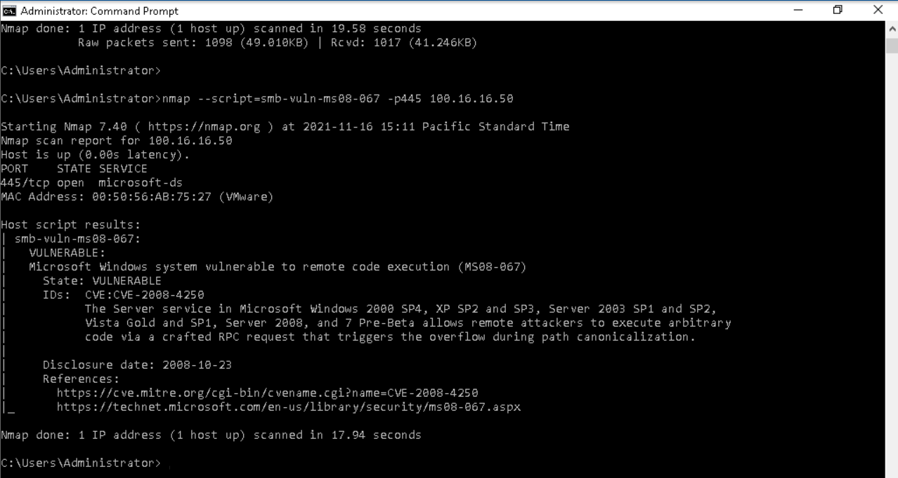

At the command prompt, type nmap -O -v 100.20.9.25 and press Enter to use Nmap to detect the operating system (-O) of the TargetWindows04 machine (100.20.9.25) with increased output verbosity (-v)

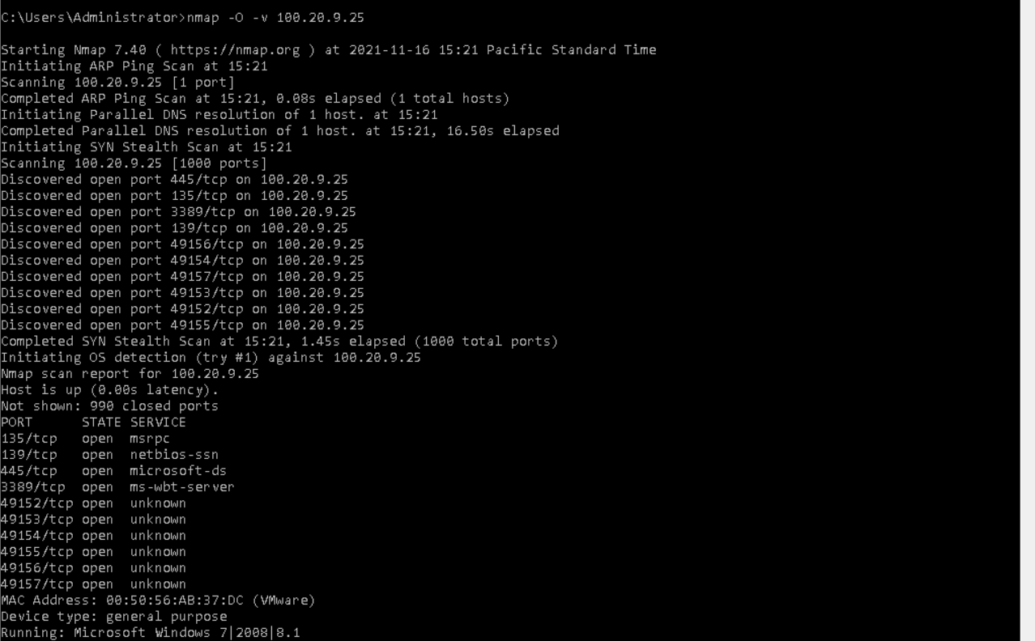

At the prompt, type nmap --script=smb-vuln-ms08-067 --script-args=unsafe=1 -p445 100.20.9.25 and press Enter to run the SMB vulnerability check on TargetWindows04 using the unsafe flag

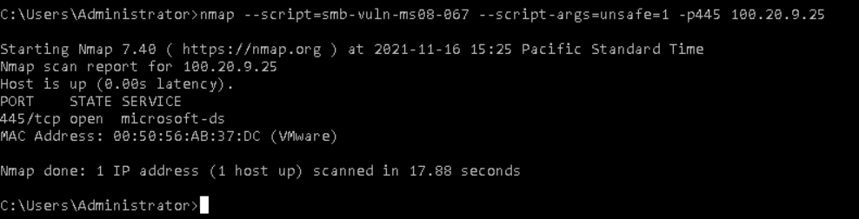

At the prompt, type nmap -O -v 100.30.10.238 and press Enter to use Nmap to detect the operating system (-O) of the TargetNMAP machine (100.30.10.238) with increased output verbosity (-v)

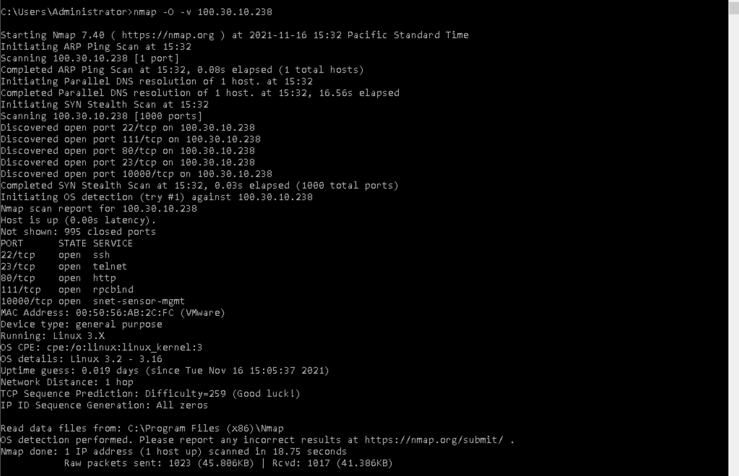

At the prompt, type nmap --script=ssh-hostkey --script-args=unsafe=1 -p22 100.30.10.238 and press Enter to run a script checking port 22 on the TargetNMAP machine for a ssh-hostkey vulnerability

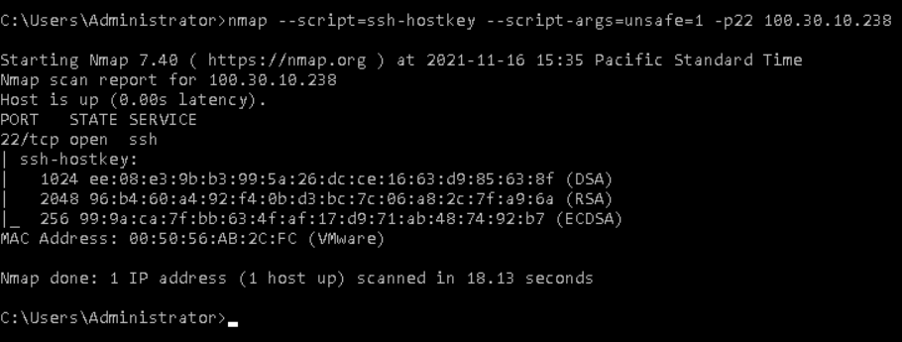

At the prompt, type nmap -O -v 172.30.0.31 and press Enter to use Nmap to detect the operating system (-O) of the TargetWindows05 machine (172.30.0.31) with increased output verbosity (-v)

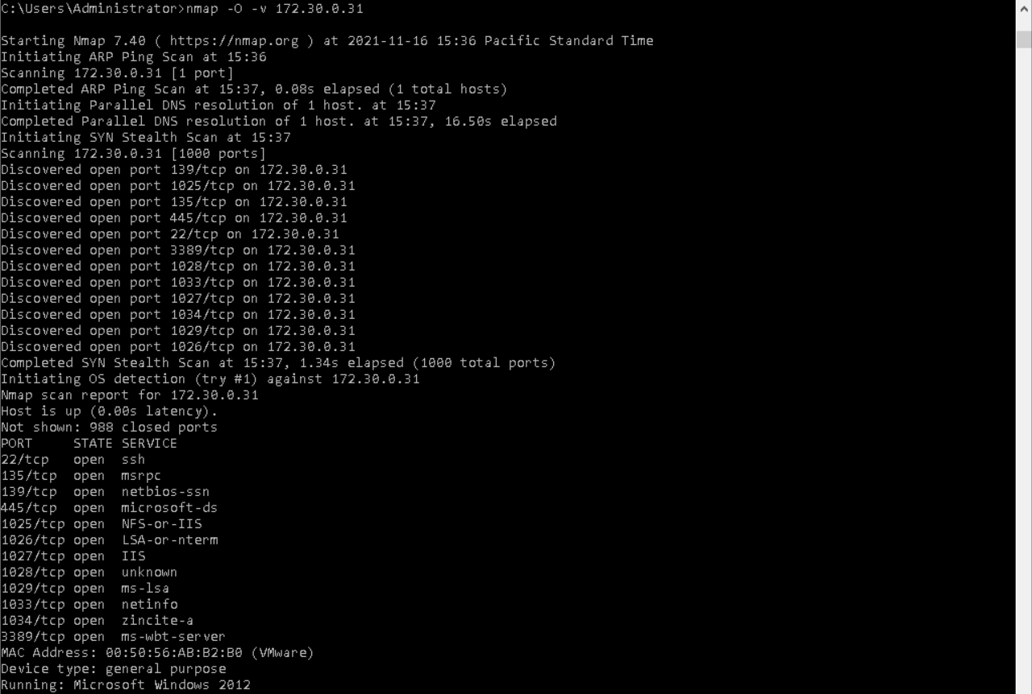

Part 2: Clean Vulnerable Systems

In the ClamWin Preferences dialog box, on the General tab, click the Remove (Use Carefully) radio button to force ClamWin to remove any infected files it identifies as part of a scan

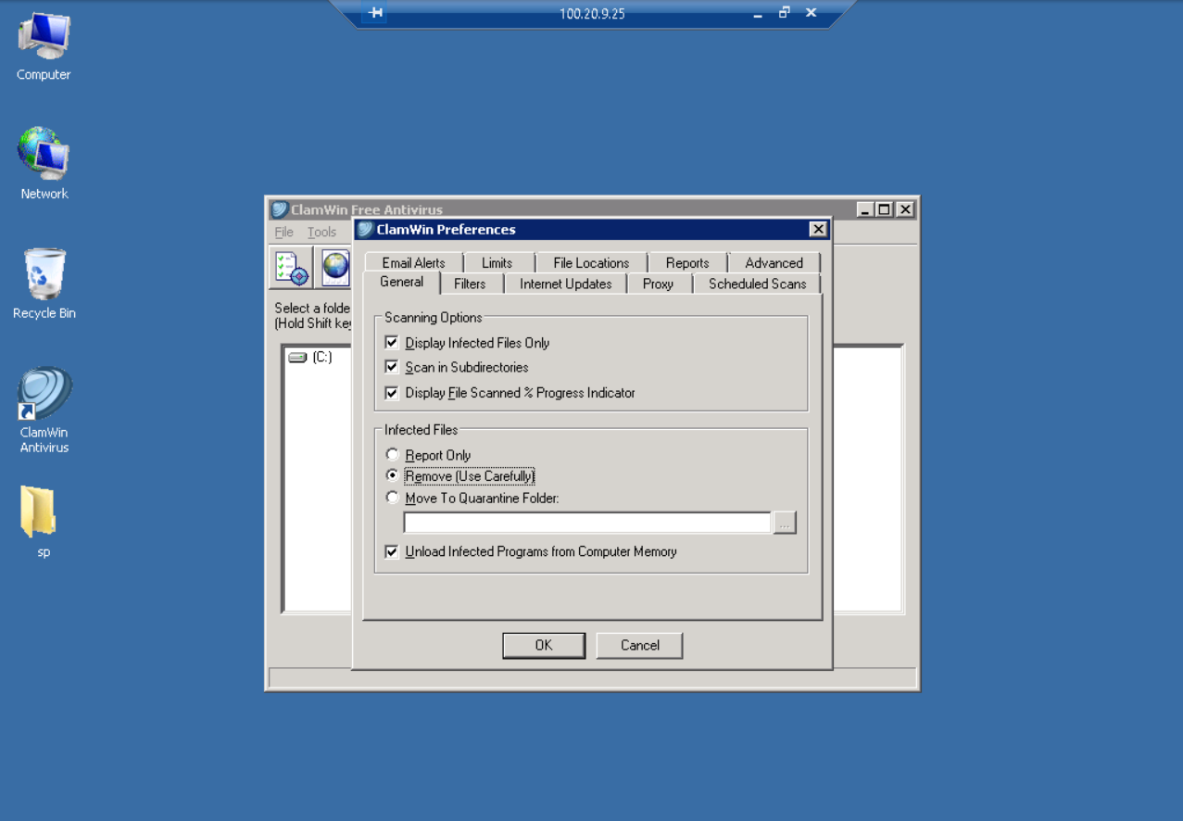

When the scan is complete, use the scrollbar to view the top of the Scan Report and verify that ClamWin removed the infected files

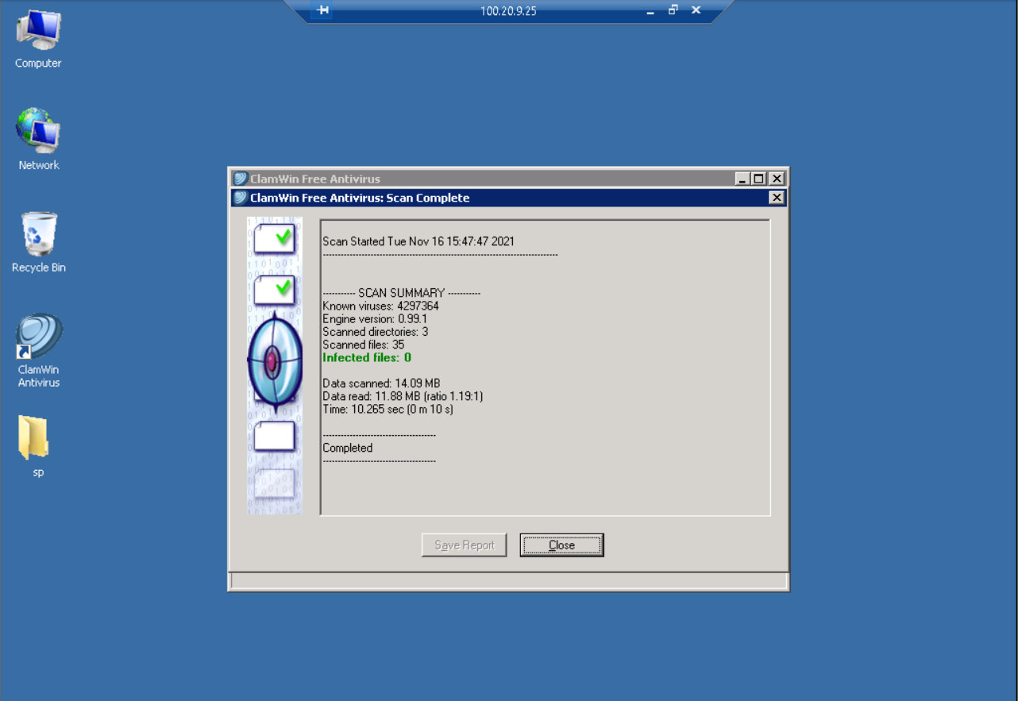

On the TargetWindows05 desktop, double-click the AVG Protection icon to open the AVG application

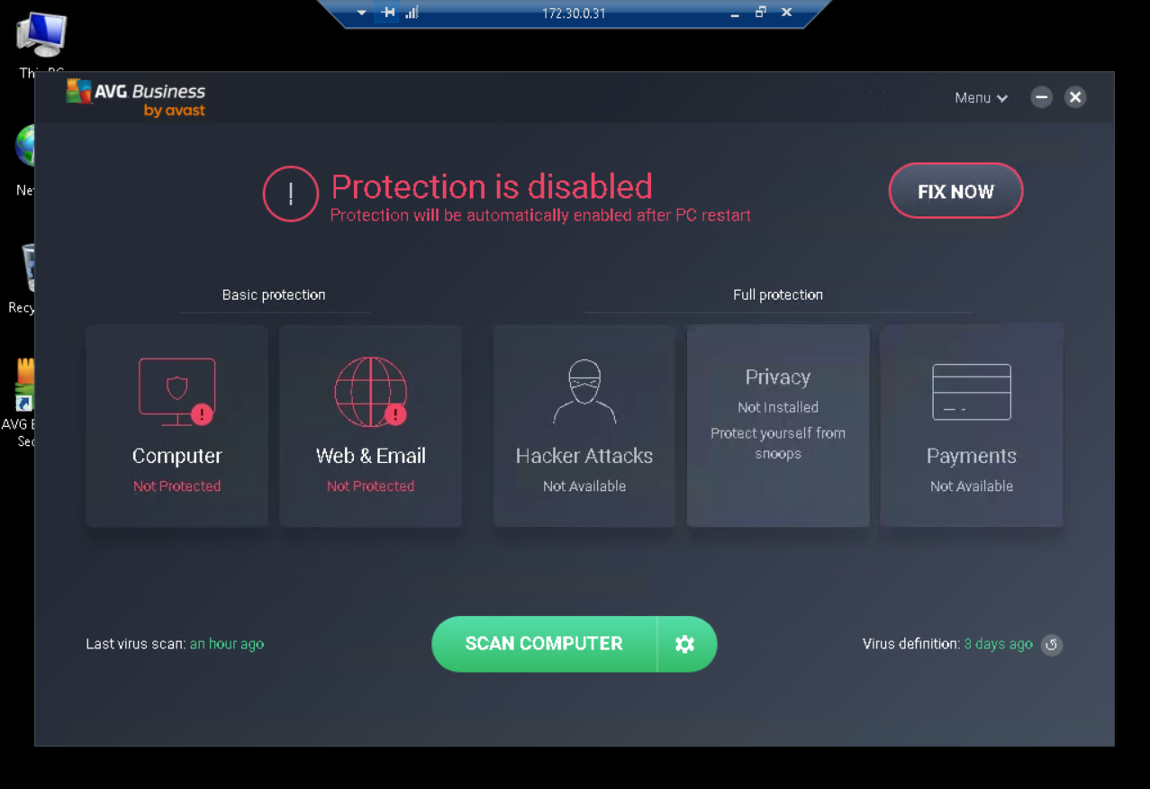

On the AVG Home page, click the Fix Now button to enable the antivirus protection on all components

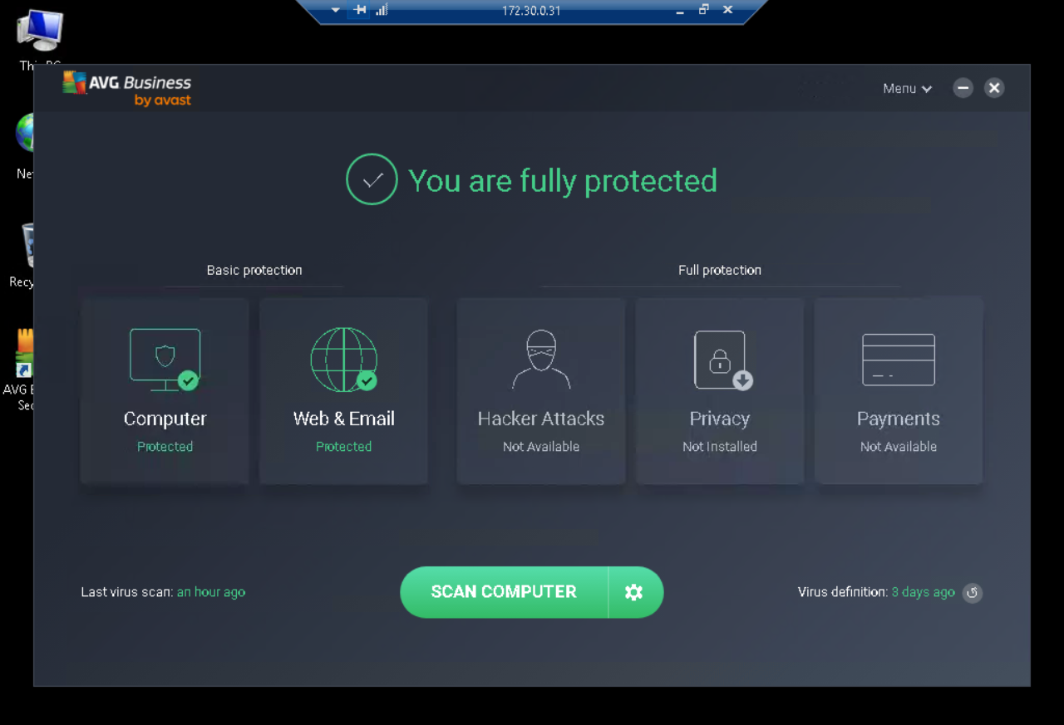

On the AVG Home page, click the Configuration button (the gear icon to the right of the Scan Computer button) to open the Other Scans page

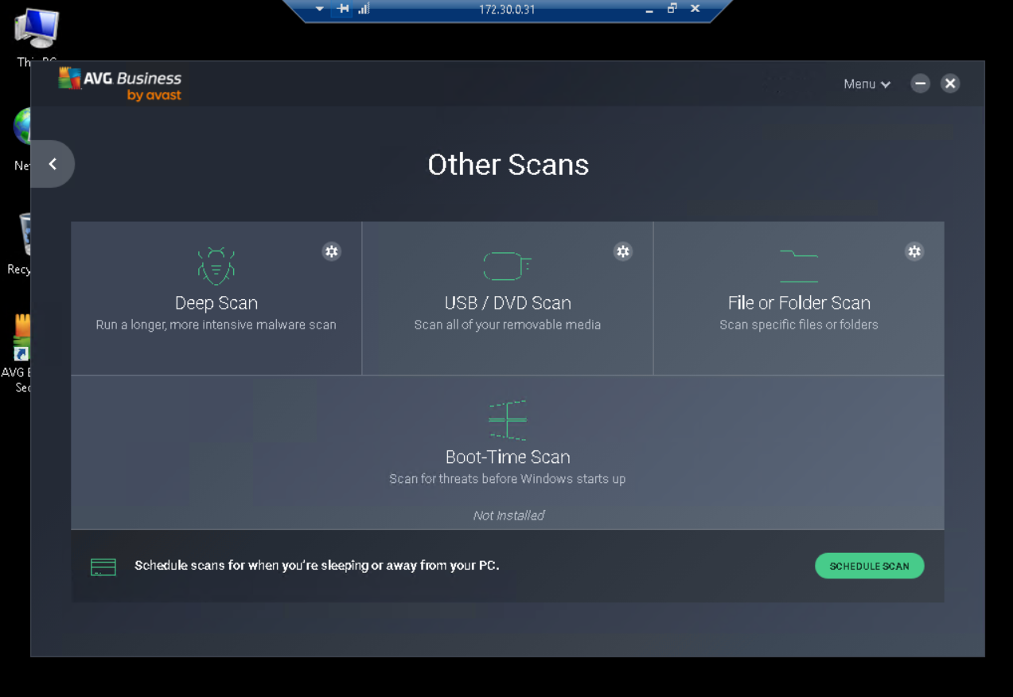

On the Other Scans page, click the File or Folder Scan button to open the Select the areas dialog box

In the Select the areas dialog box, navigate to the Desktop (C:\Users\Administrator\Desktop), then select the Desktop checkbox to narrow the scope of the scan to desktop folder

Click OK to begin the scanning process and remove any identified threats. When the scan is completed, AVG will display a screen indicating any threats that it has identified and removed. On the Scan Summary page, hover your cursor over the first threat to see more details about the threat

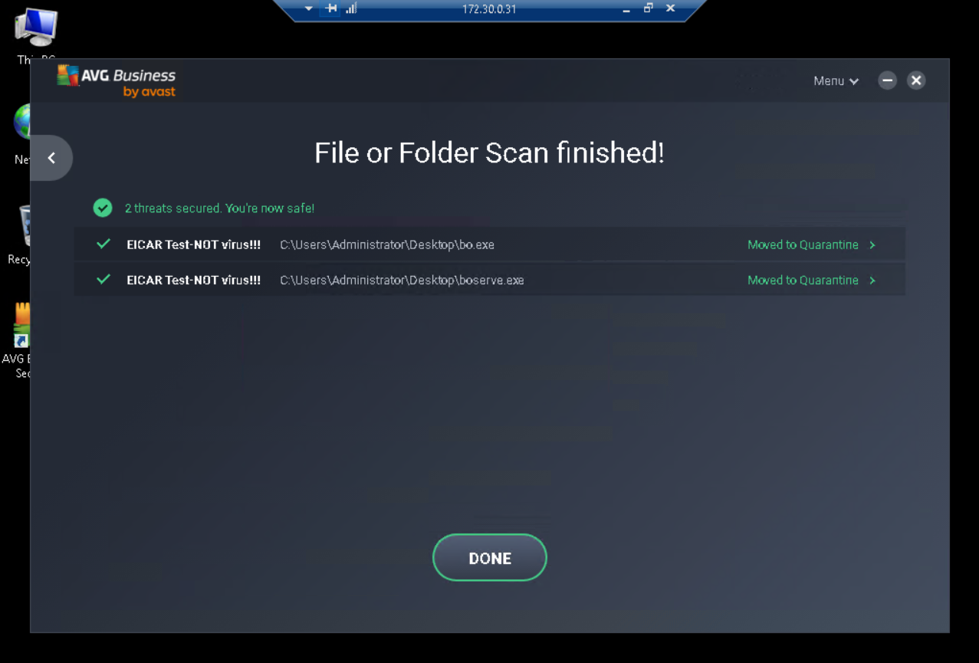

Part 3: Reduce the Attack Surface on the Windows 2003 Server

On the TargetVulnerable01 desktop, right-click the My Network Places icon and select Properties from the context menu

In the Network Connections window, right-click the Local Area Connection icon and select Properties from the context menu

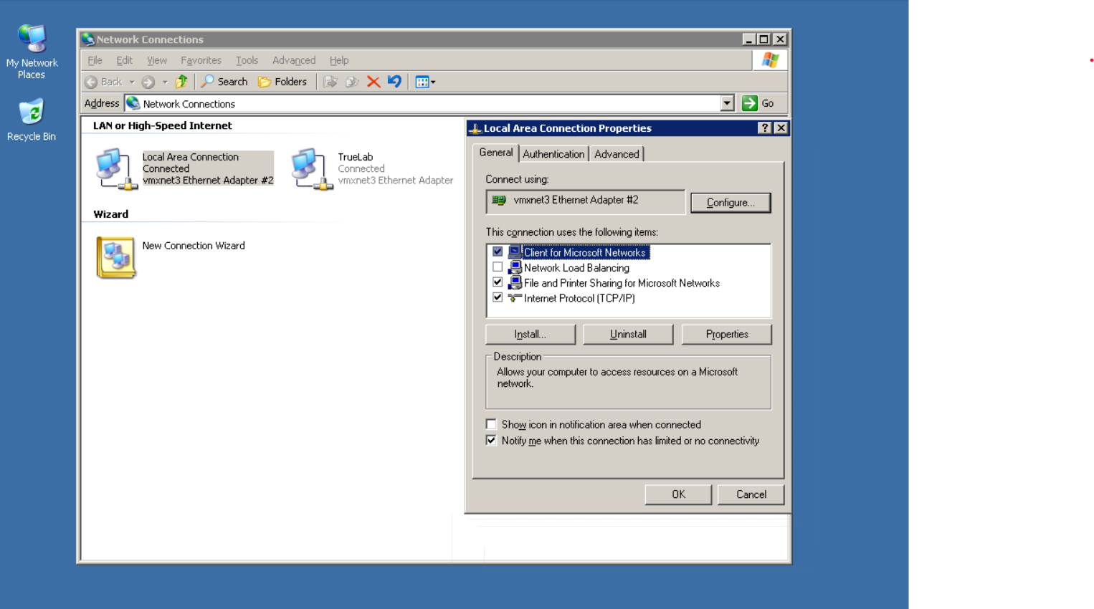

On the Advanced tab, click the Settings button to edit the Windows Firewall settings

When prompted, click Yes to activate Windows Firewall/Internet Connection Sharing (ICS)

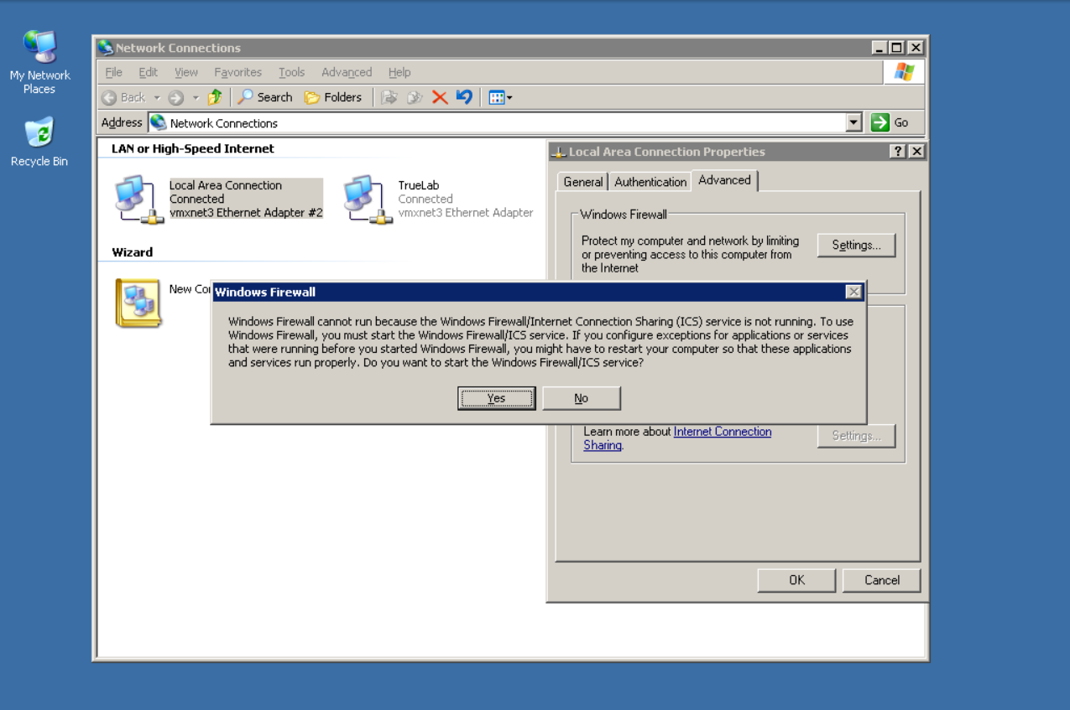

In the Windows Firewall dialog box, click the Exceptions tab

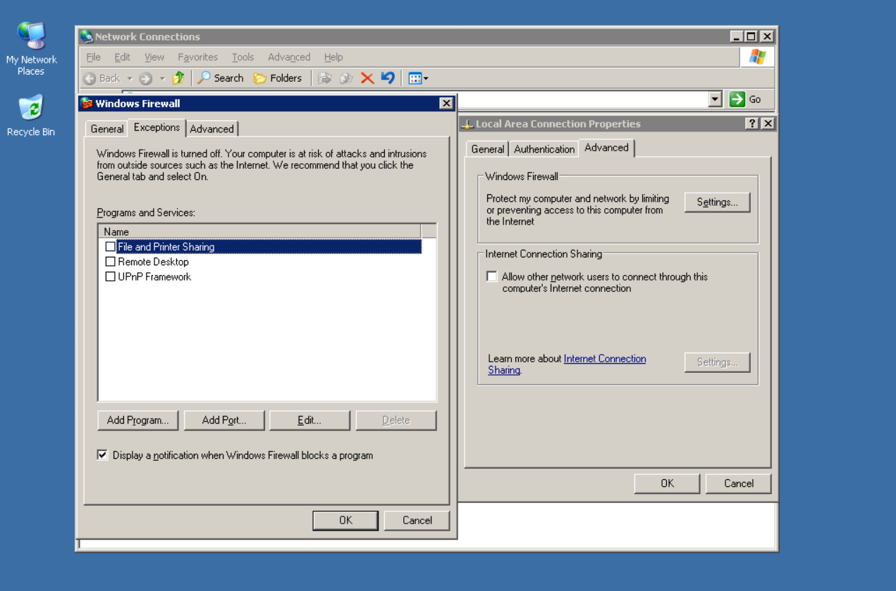

In the Programs and Services list, click the Remote Desktop checkbox to prevent the Remote Desktop service from being blocked by Windows Firewall

The Remote Desktop Protocol is used in the virtual lab to make these remote connections. It must remain on for the vWorkstation, but should not be enabled for any other machines

At the bottom of the Exceptions tab, click the Edit button to open the Service Editor

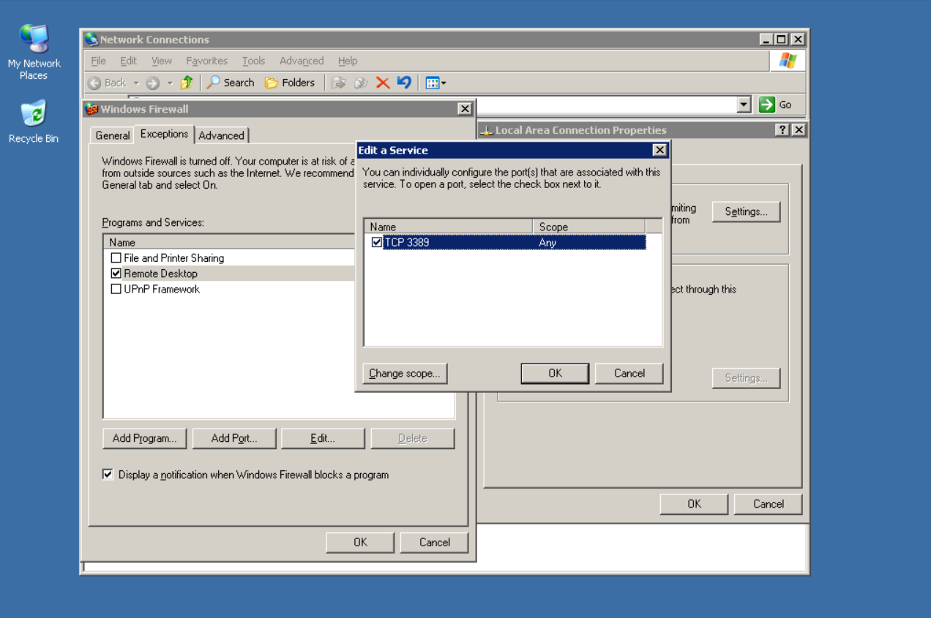

In the Service Editor, click the Change Scope button.

In the Change Scope window, click the Custom List radio button, then type 172.30.0.2,100.16.16.2 in the text box and click OK to limit the hosts allowed to use the remote desktop service to the vWorkstation and TargetVulnerable01

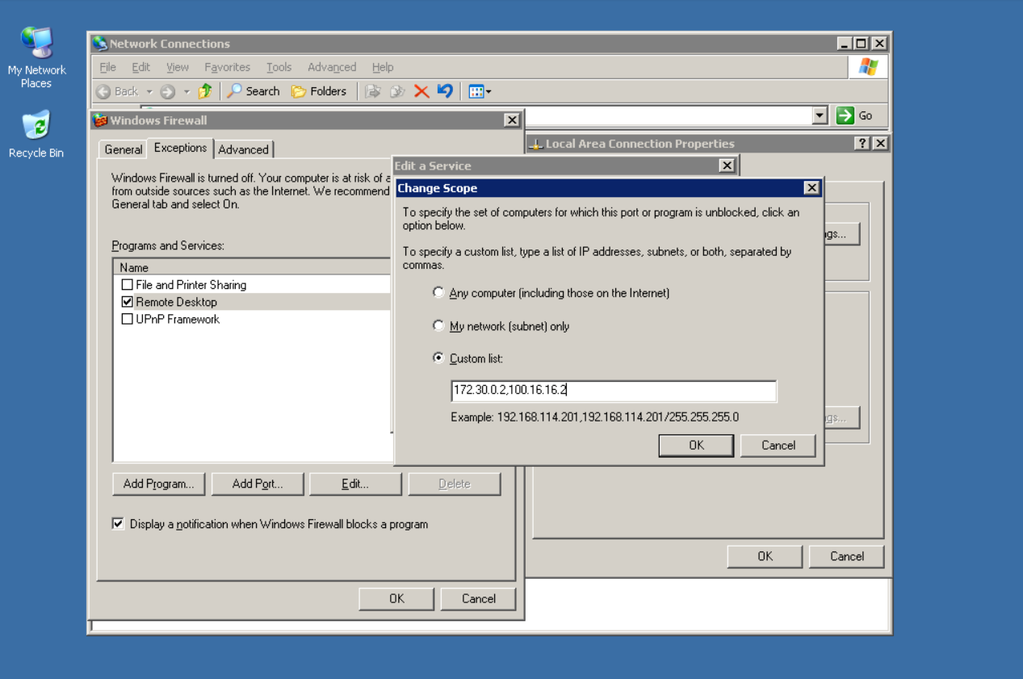

In the Network Connection Settings section, click the Settings button to open the Advanced Settings dialog box

In the Advanced Settings window, click the ICMP tab to view the advanced ICMP settings

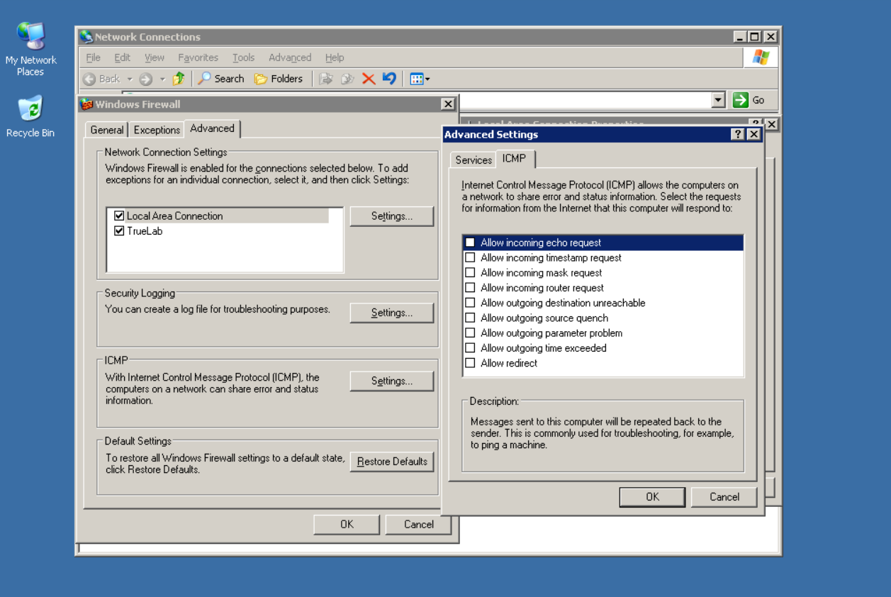

On the ICMP tab, click the Allow incoming echo request checkbox, then click OK to limit the Ping requests that this computer will respond to

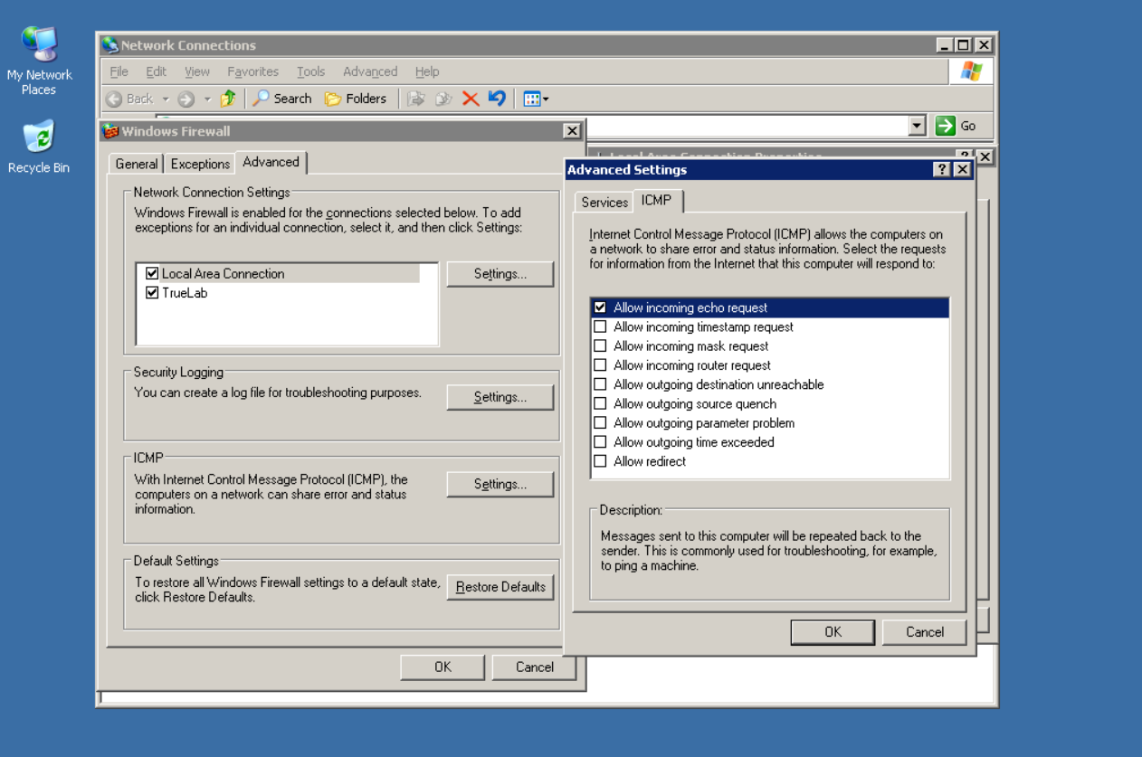

In the Security Logging section, click on the Settings button to open the Log Settings dialog box

Click the Log dropped packets and the Log successful connections checkboxes and click OK to log these events and close the Log Settings window

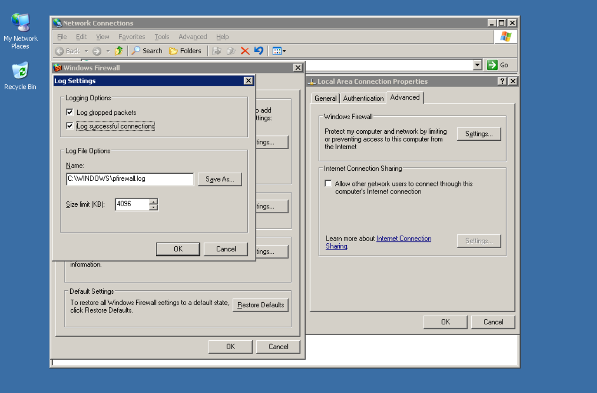

In the Windows Firewall dialog box, click the General tab and click the On radio button to activate the Windows Firewall, then click OK to close the Windows Firewall configuration window

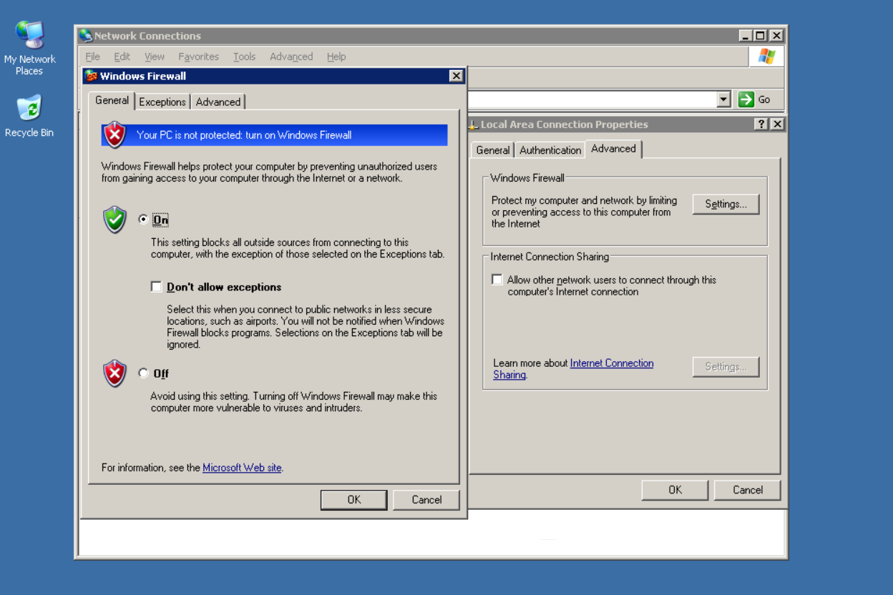

From the vWorkstation taskbar, click the Command Prompt icon to restore the command prompt window

At the command prompt, type nmap -O -v 100.16.16.50 and press Enter to re-run the Nmap operating system detection scan on the TargetVulnerable01 machine

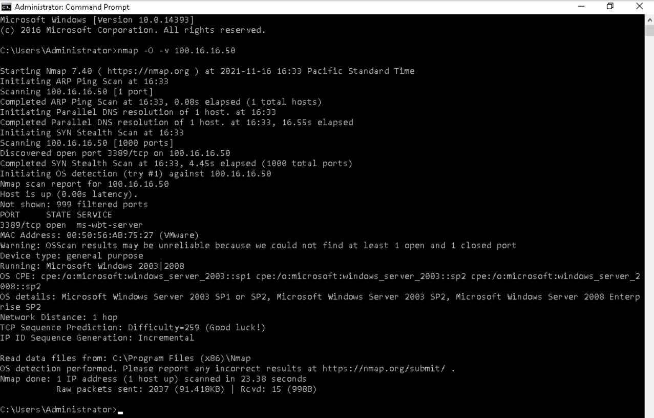

Part 4: Reduce the Attack Surface on the Windows 2008 Server

From the TargetWindows04 taskbar, click the Windows Start menu and select Administrative Tools > Windows Firewall with Advanced Security to open the firewall settings

In the left pane, click the Inbound Rules link to view all of the existing rules

In the Actions pane at the top right of the window, click the Filter by State rule and select Filter by Enabled from the context menu to view only the enabled rules

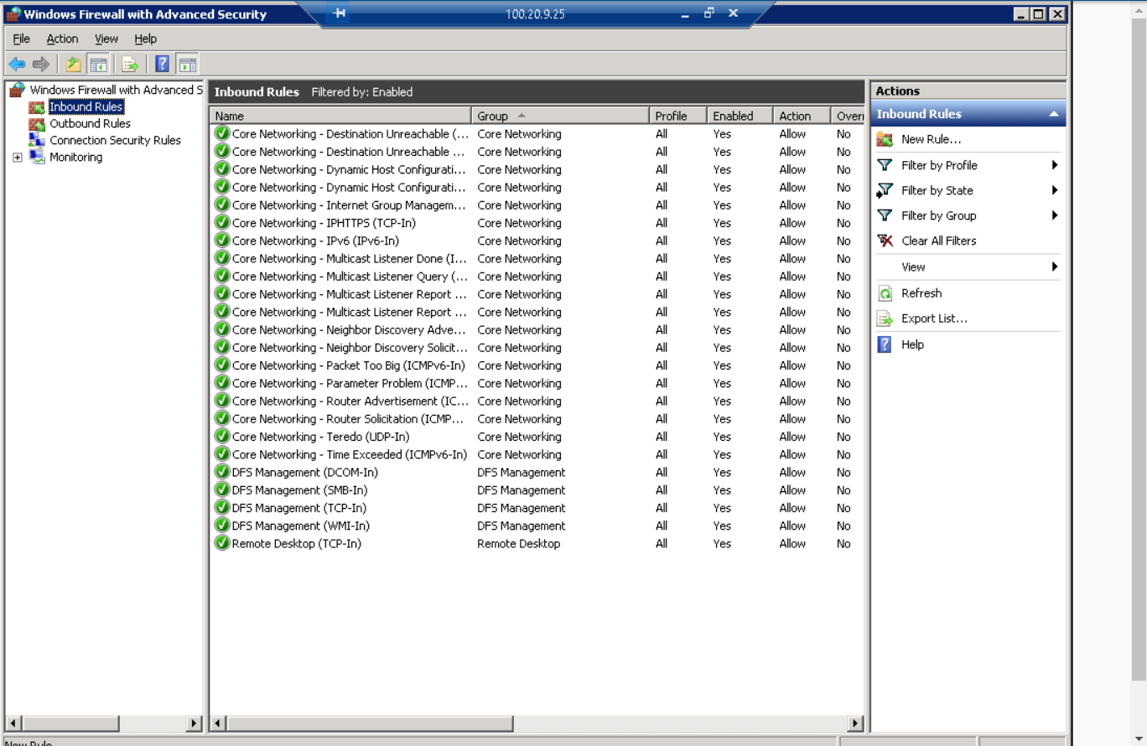

For each rule except the Remote Desktop (TCP-In) rule, select the rule and click Disable Rule in the Selected Items section of the right pane. You can also select a range of rules by holding down the Shift key and selecting the rule at each end of the desired range, then deactivate them as a batch.

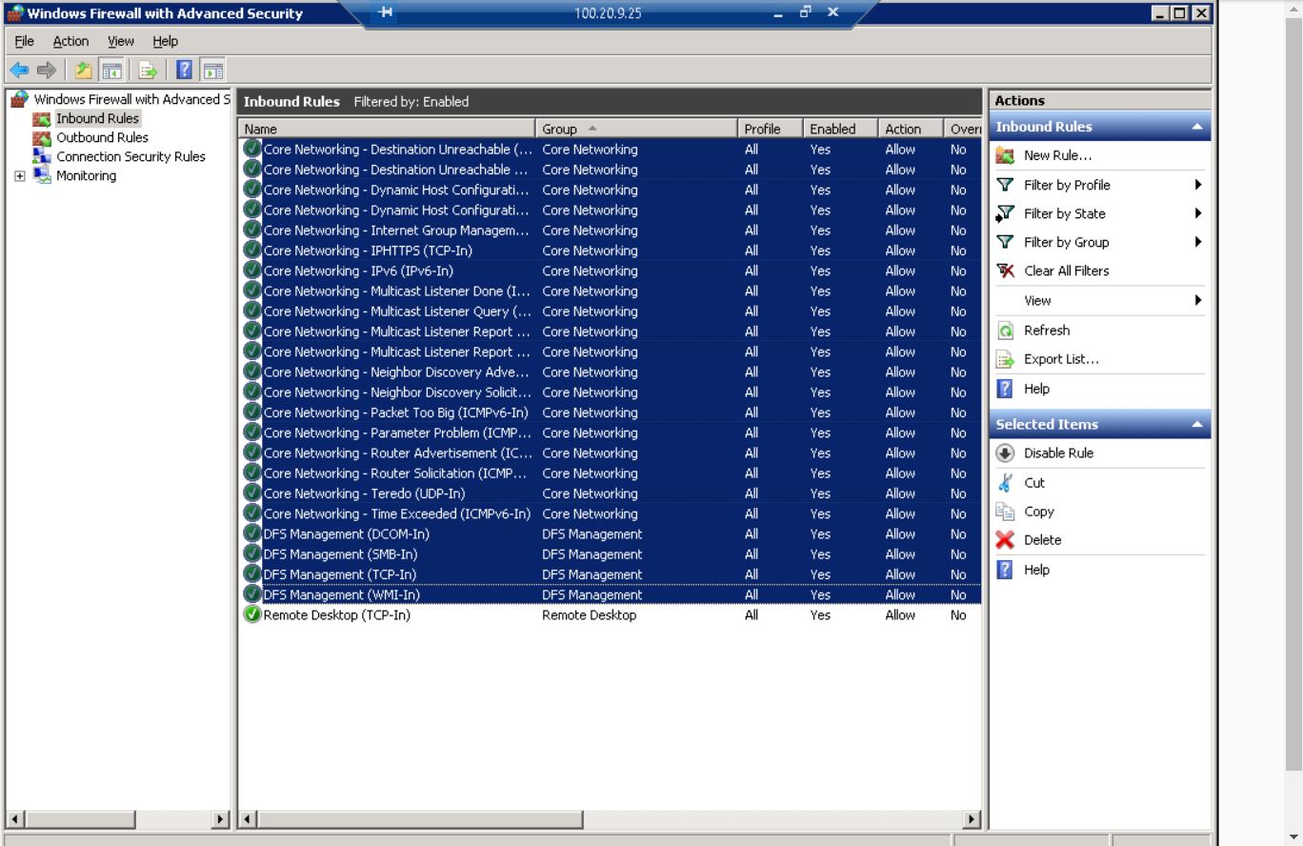

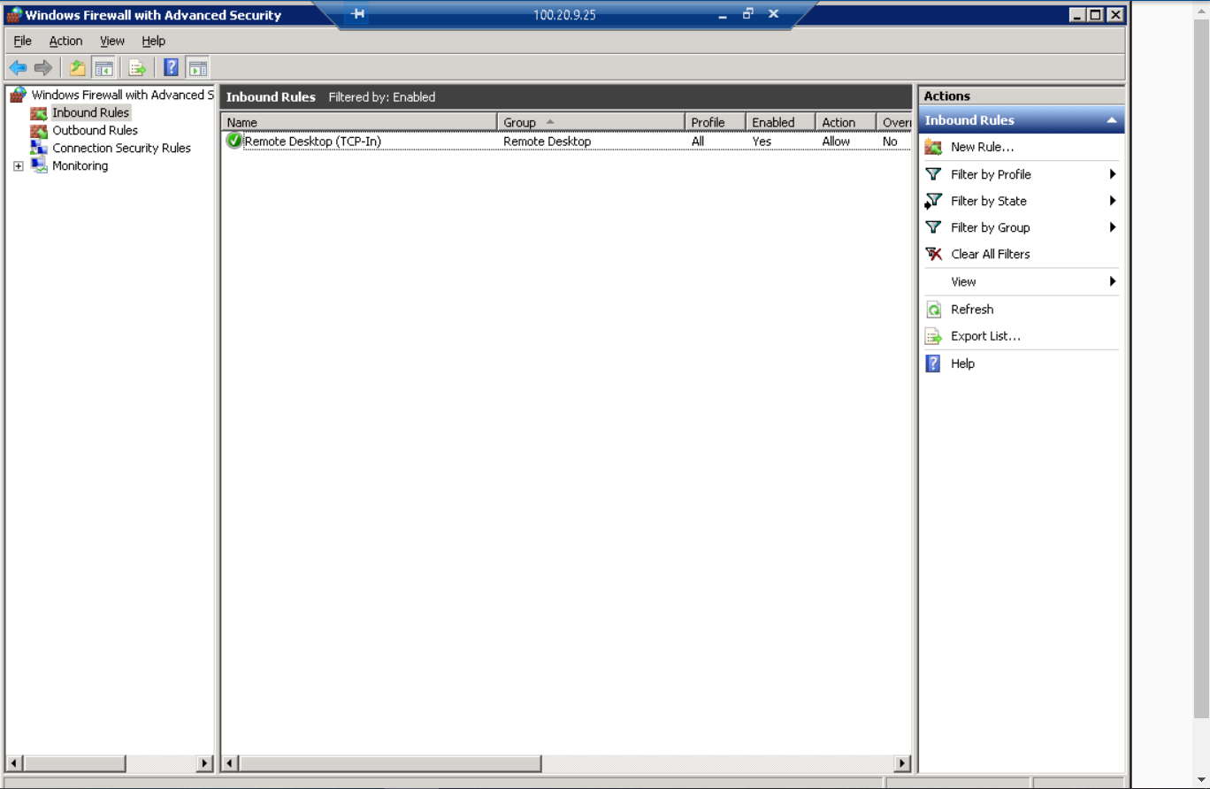

Add a new rule link to allow ICMP

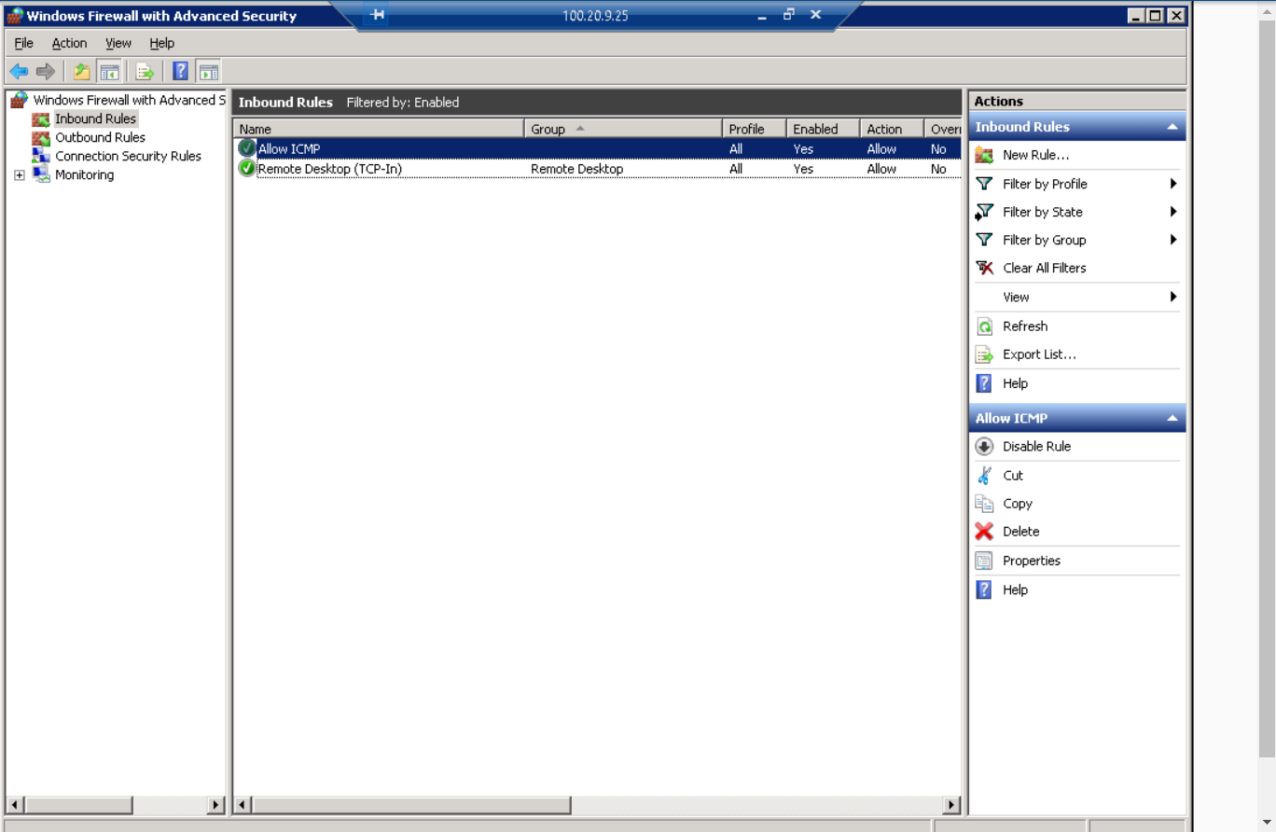

Activate windows firewall for the domain profile, private profile and public profile

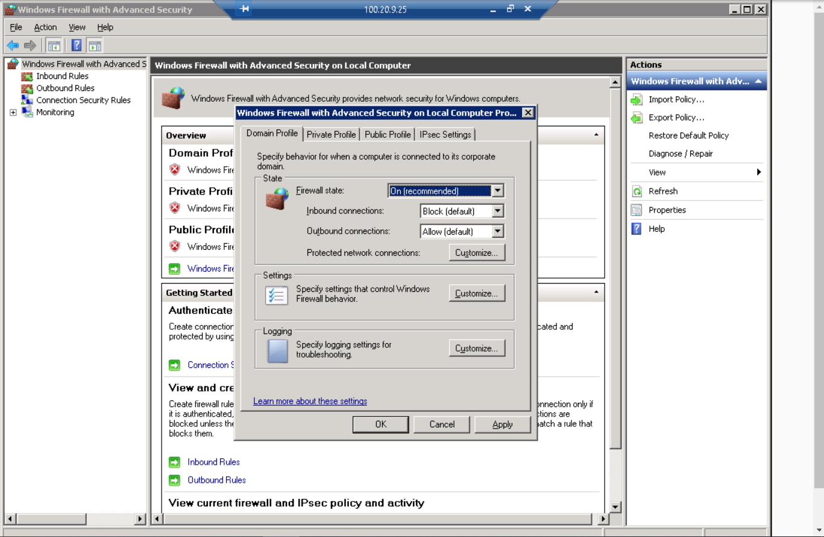

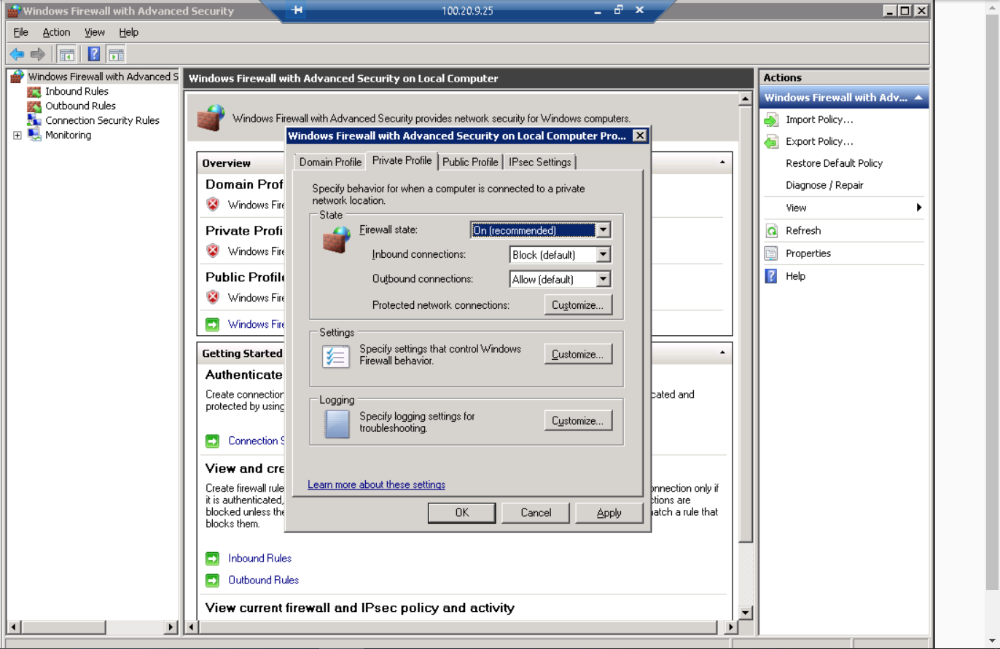

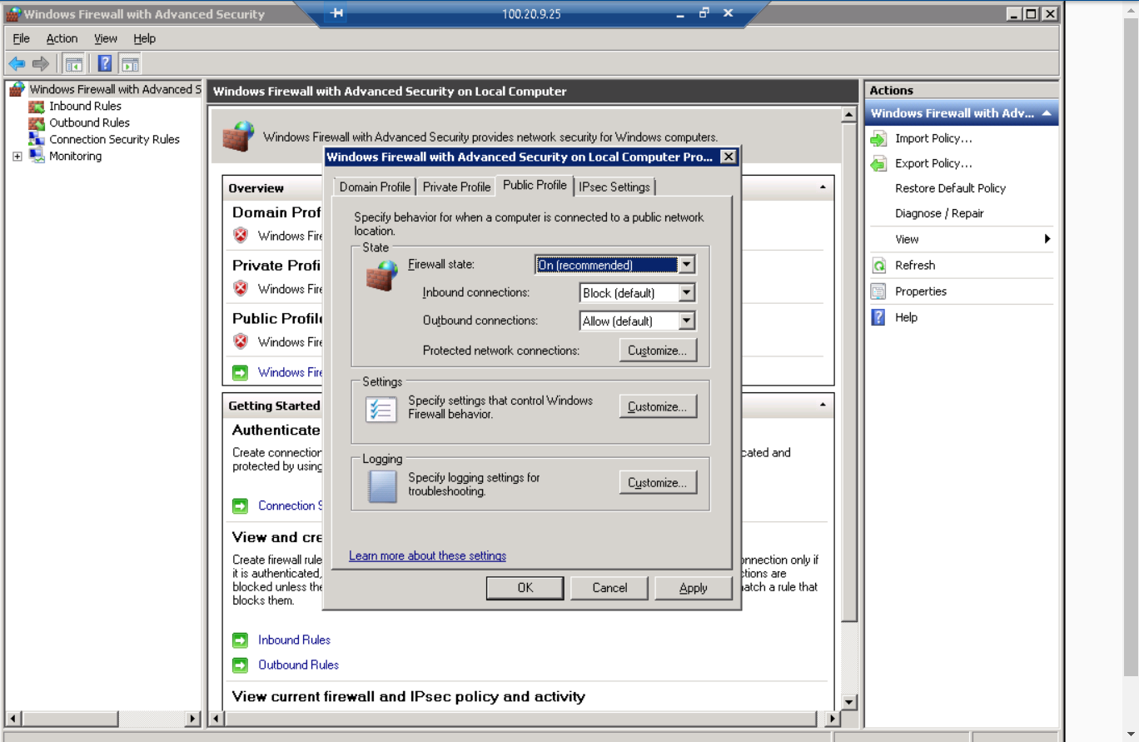

At the command prompt, type nmap -O -v 100.20.9.25 and press Enter to re-run the Nmap operating system detection command. Note: The only port left open should be the Remote Desktop Service (port 3389)

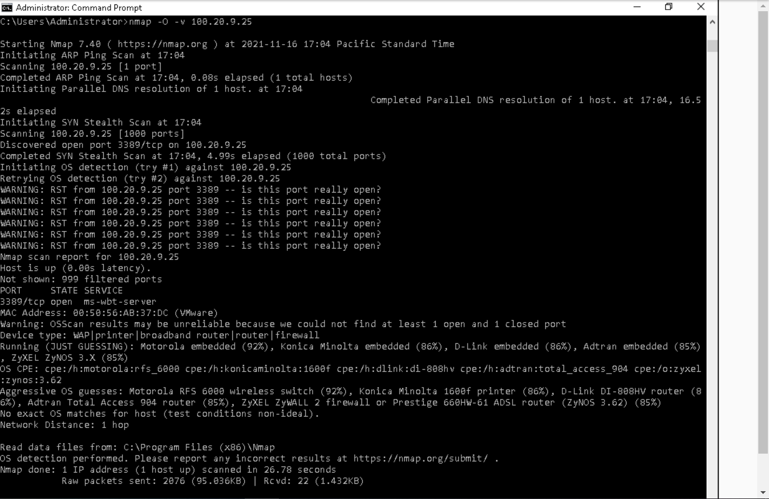



**Section 2: Applied Learning**

-D Decoy IP addresses

-sS Stealth Scan

Part 1: Scan the Wide Area Network

At the command prompt, execute tcpdump -i eth0 port 80 -w yourname_capture_S2, replacing yourname with your own name, to start capturing traffic on this machine and saving the results to a file named yourname_capture_S2

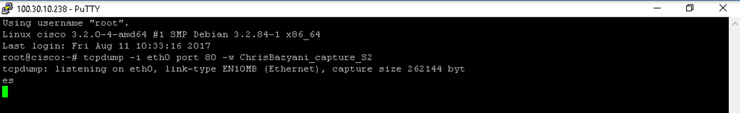

At the command prompt, execute nmap -sS -p 80 100.30.10.238 -D 88.77.66.44,33.22.11.1,95.85.75.65 to start a stealth scan (-sS) of port 80 (-p 80) on the TargetNMAP machine (100.30.10.238) with decoy IP addresses (88.77.66.44, 33.22.11.1, and 95.85.75.65)

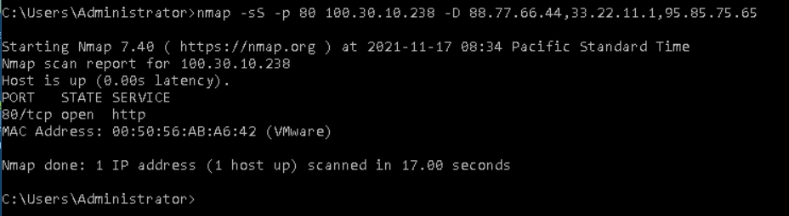

When the nmap scan is complete, restore the TargetNMAP window and press Ctrl+C to stop the capture

At the TargetNMAP command prompt, execute tcpdump -r yourname_capture_S2, replacing yourname with your own name, to read (-r) the capture file

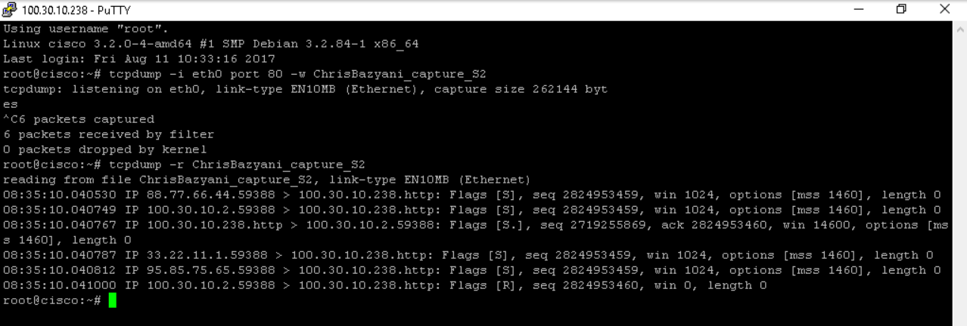

At the vWorkstation command prompt, execute the Nmap command to detect the operating system of the TargetVulnerable01 machine with increased output verbosity

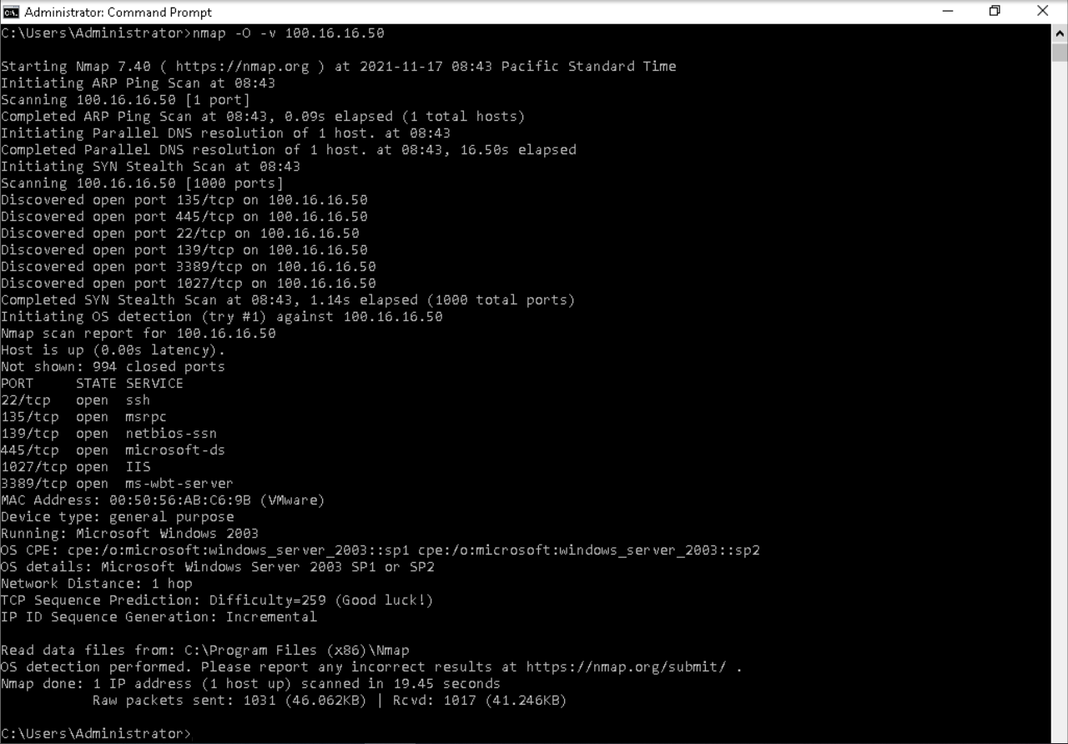

At the prompt, execute nmap --script=smb-vuln-ms08-067 -p445 100.16.16.50 to run a script checking port 445 on the TargetVulnerable01 machine for a SMB vulnerability, specifically the MS08-067 exploit

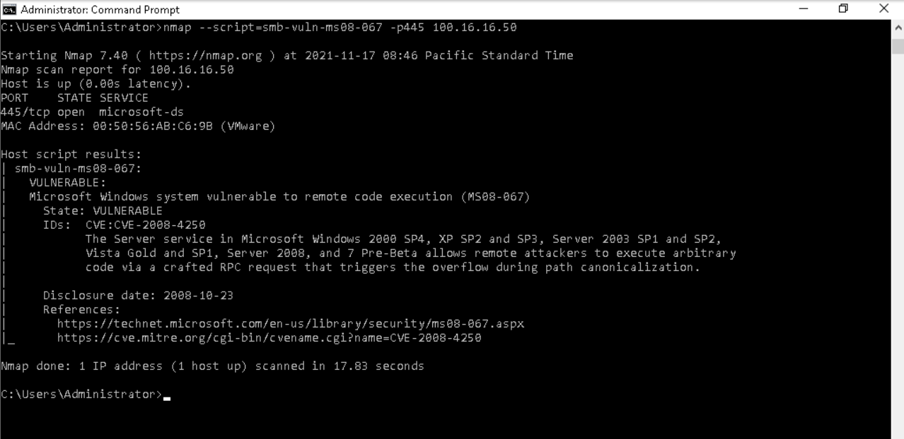

At the prompt, execute the Nmap command to detect the operating system of the TargetWindows04 machine with increased output verbosity

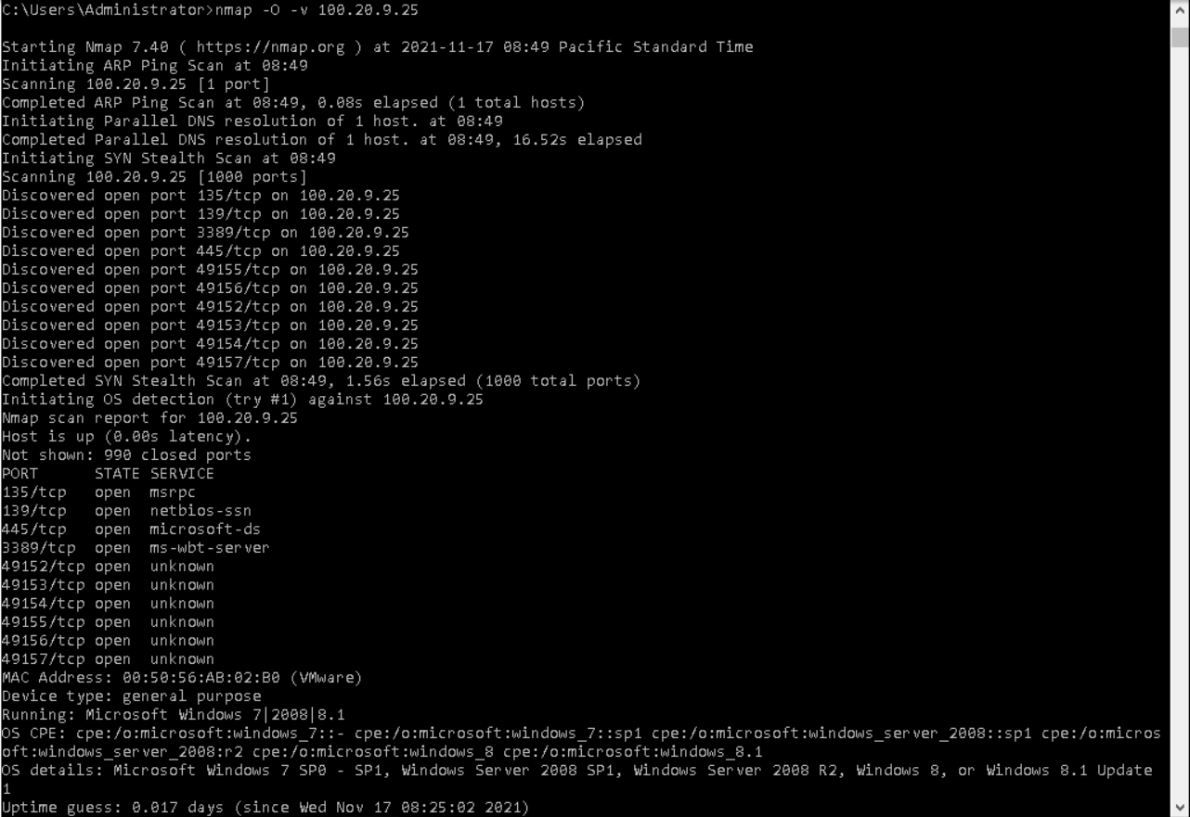

At the prompt, execute nmap --script=smb-vuln-ms08-067 --script-args=unsafe=1 -p445 100.20.9.25 to run the SMB vulnerability check on TargetWindows04 using the unsafe flag

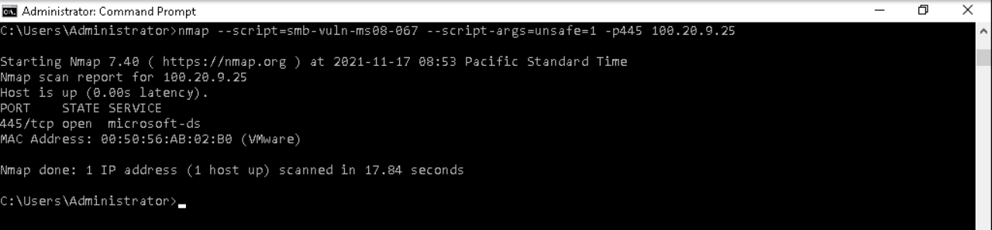

At the command prompt, execute the Nmap command to detect the operating system of the TargetNMAP machine with increased output verbosity

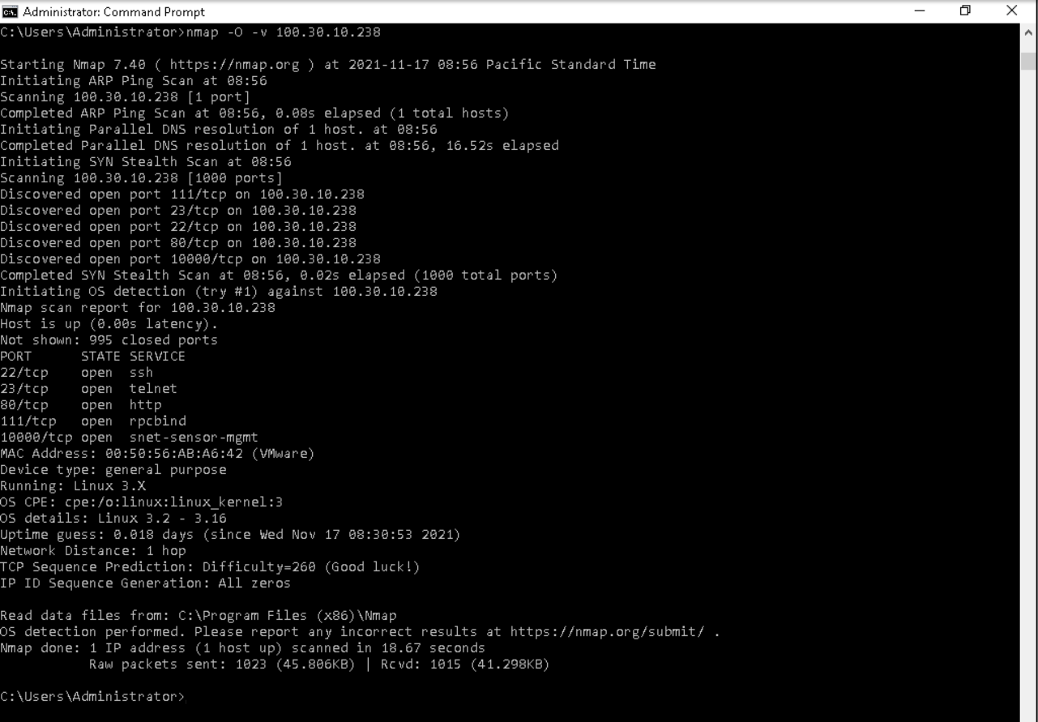

At the prompt, execute nmap --script=ssh-hostkey --script-args=unsafe=1 -p22 100.30.10.238 to run a script checking port 22 on the TargetNMAP machine for a ssh-hostkey vulnerability

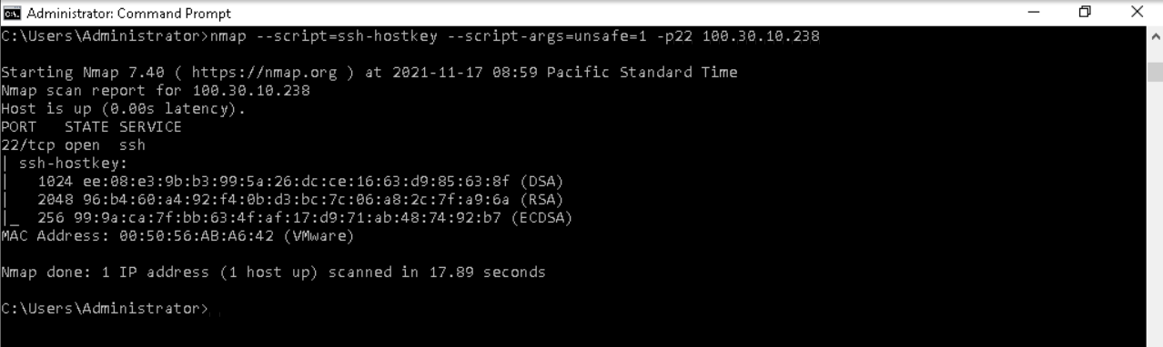

At the prompt, execute the Nmap command to detect the operating system of the TargetWindows05 machine with increased output verbosity

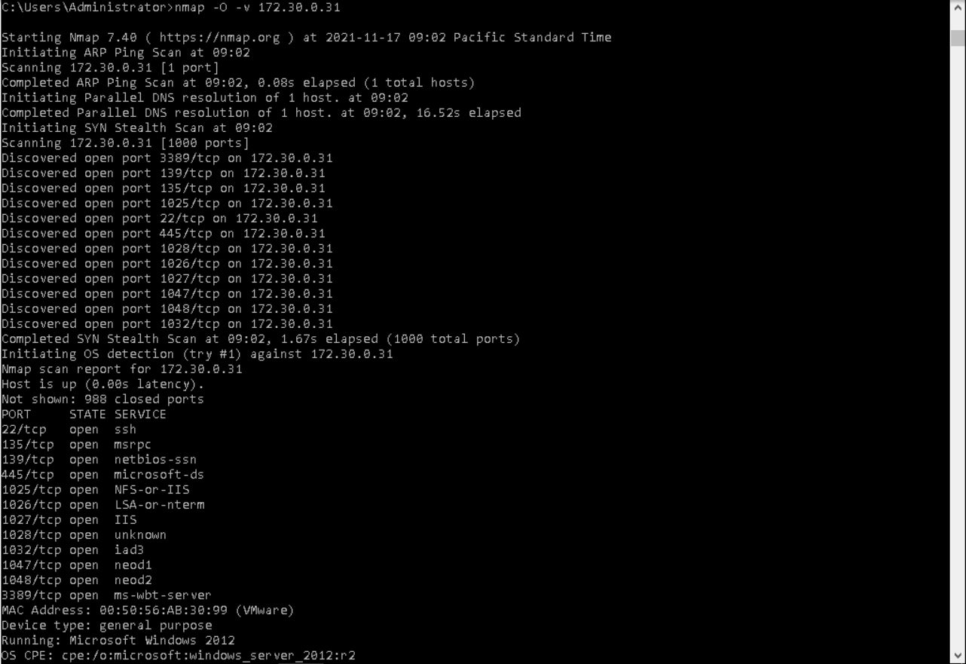

Part 2: Clean Vulnerable Systems

In the ClamWin Preferences dialog box, click the Remove (Use Carefully) radio button to force ClamWin to remove any infected files it identifies as part of a scan

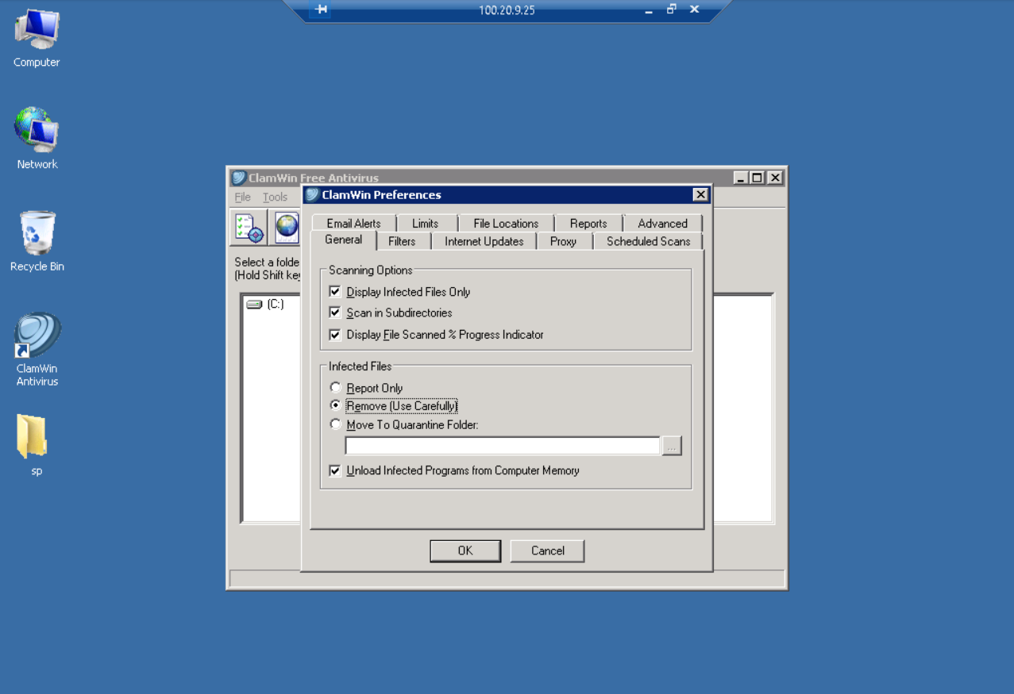

Click OK to close the Preferences dialog box, then navigate to the Users folder (C:\Users) and click Scan to begin the scan

When the scan is complete, use the scrollbar to view the top of the Scan Report and verify that ClamWin removed the infected files  
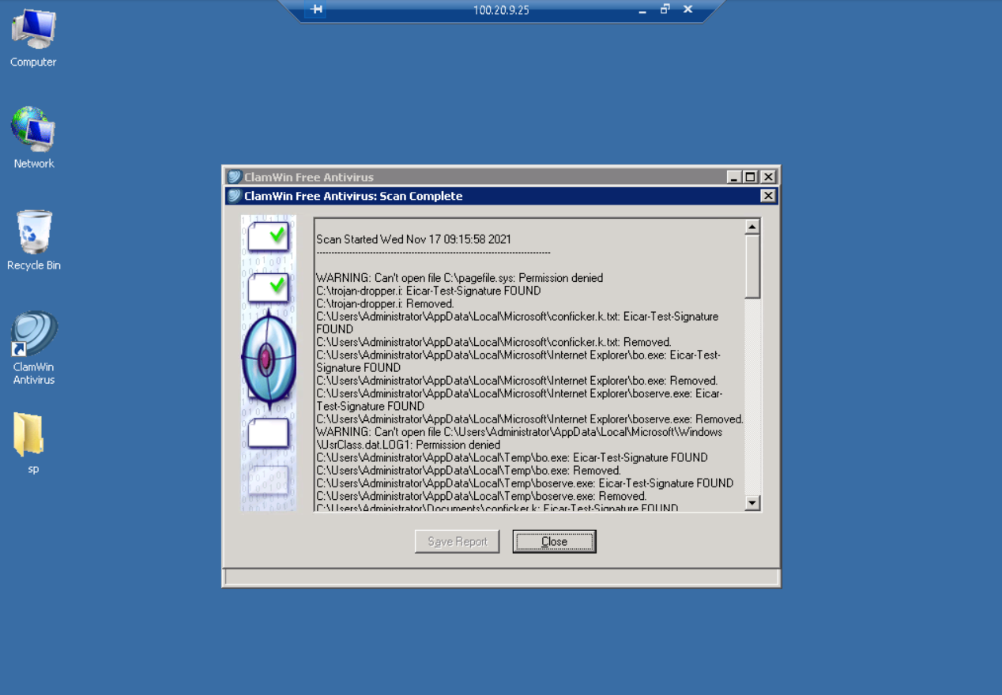

From the TargetWindows05 desktop, launch the AVG Antivirus application

On the AVG Home page, click the Fix Now button to enable antivirus protection on all components

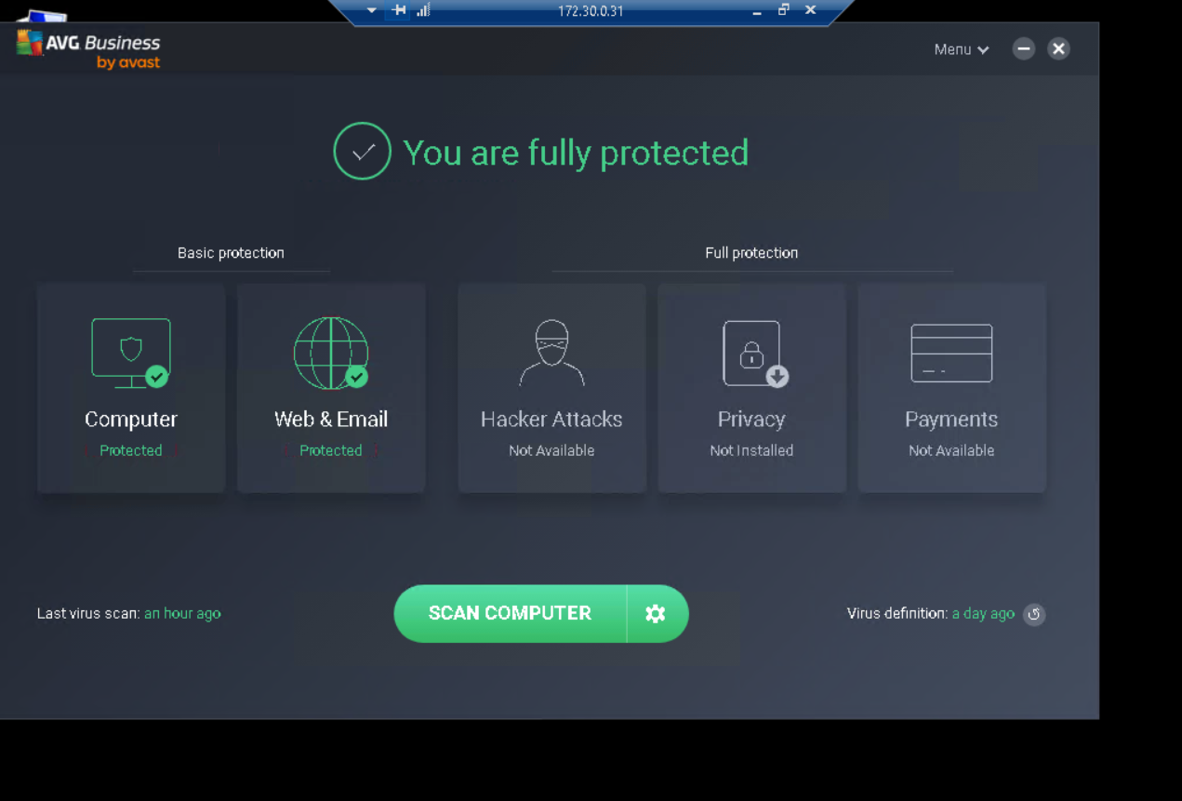

Run a Specific File or Folder Scan on the Administrator Desktop (C:\Users\Administrator\Desktop)

On the Scan Summary page, hover your cursor over the first threat to see additional details

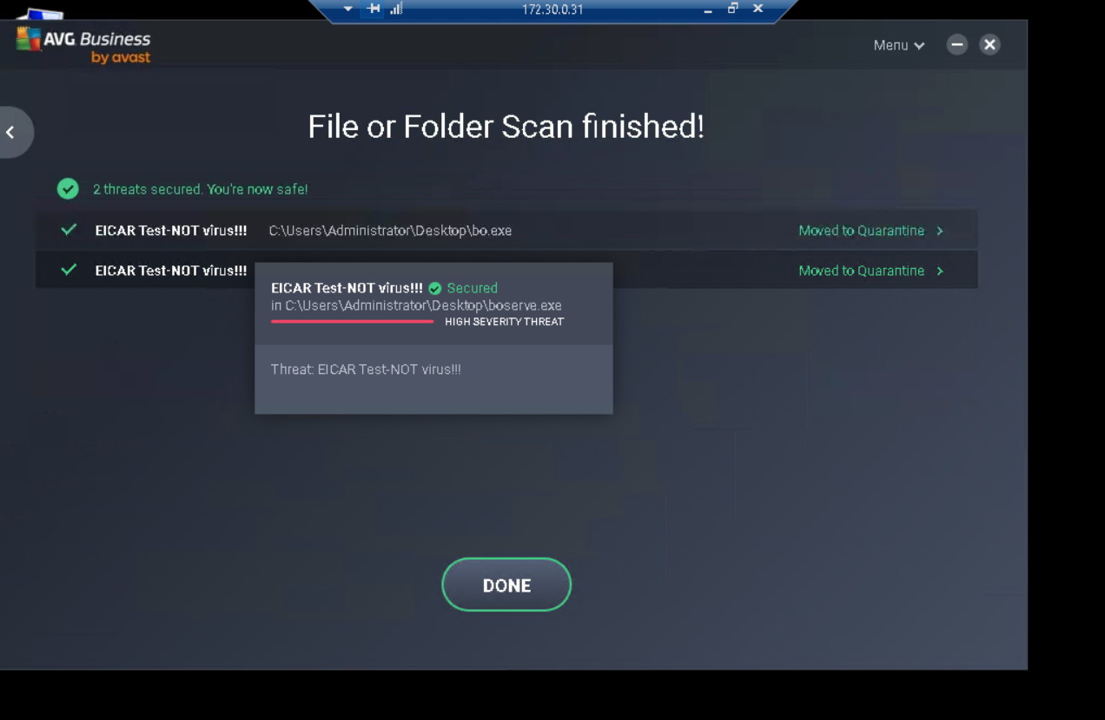

Part 3: Reduce the Attack Surface on the Windows 2003 Server

Open a remote connection to the TargetVulnerable01 machine and launch a Command Prompt window

At the command prompt, execute netsh firewall show opmode (operational mode) to display the firewall profiles

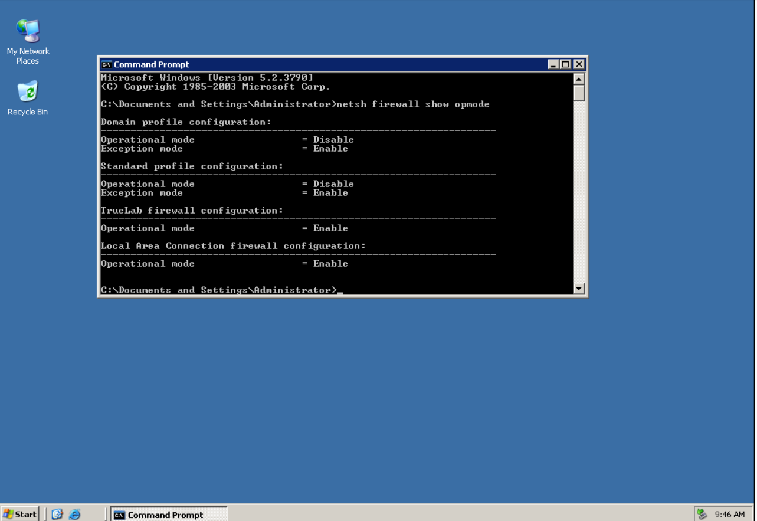

Minimize the Command Prompt window, then right-click the My Network Places and select Properties from the context menu

In the Network Connections window, right-click the Local Area Connection icon and select Properties from the context menu

In the Local Area Connection Properties dialog box, click the Advanced tab

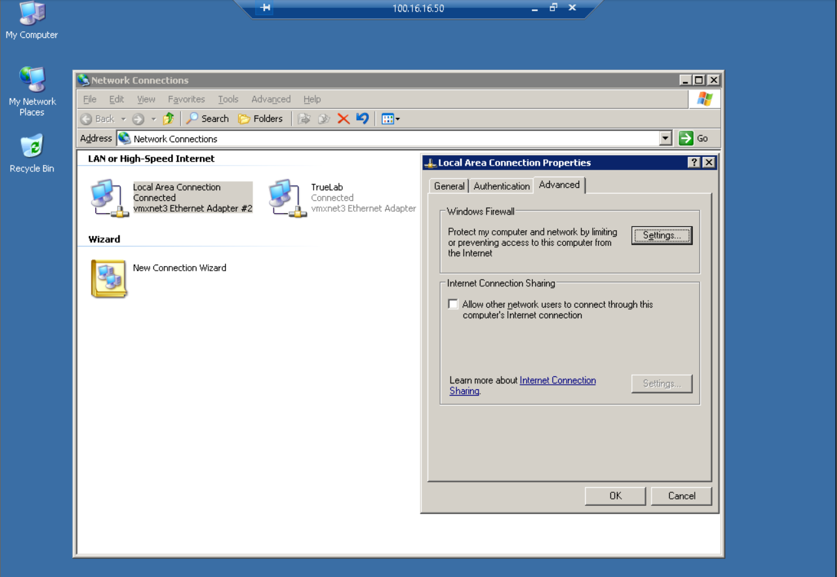

On the Advanced tab, click the Settings button and select Yes when prompted to activate Windows Firewall/Internet Connection Sharing (ICS)

Do not enable the Windows Firewall at this time. You will use the netsh command to specify ports and apply the Remote Desktop exception

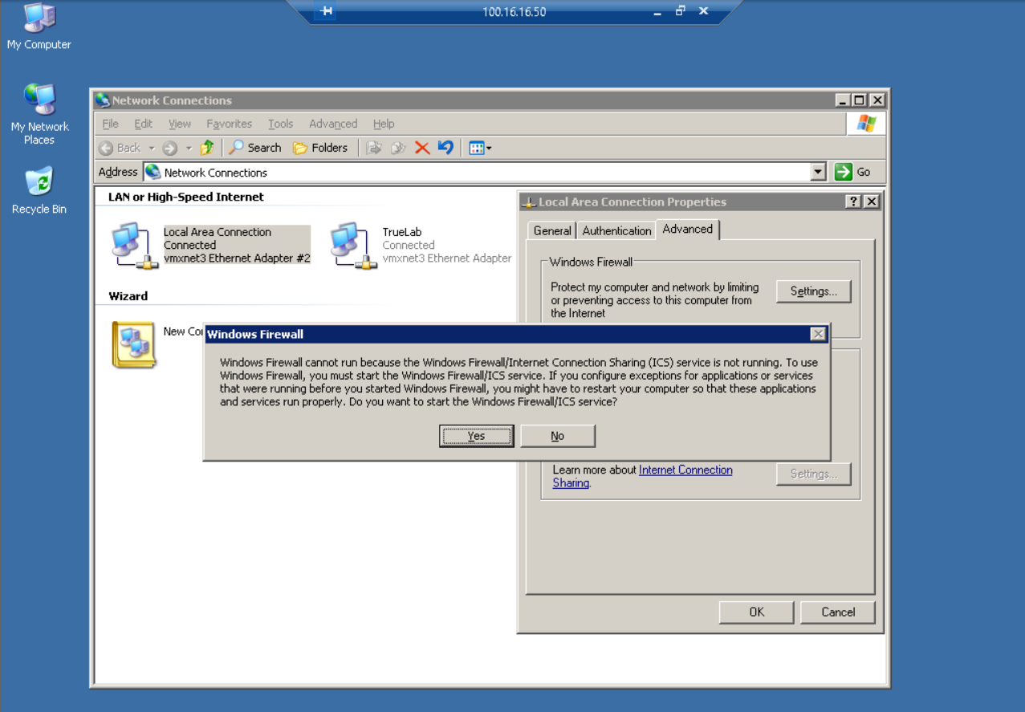

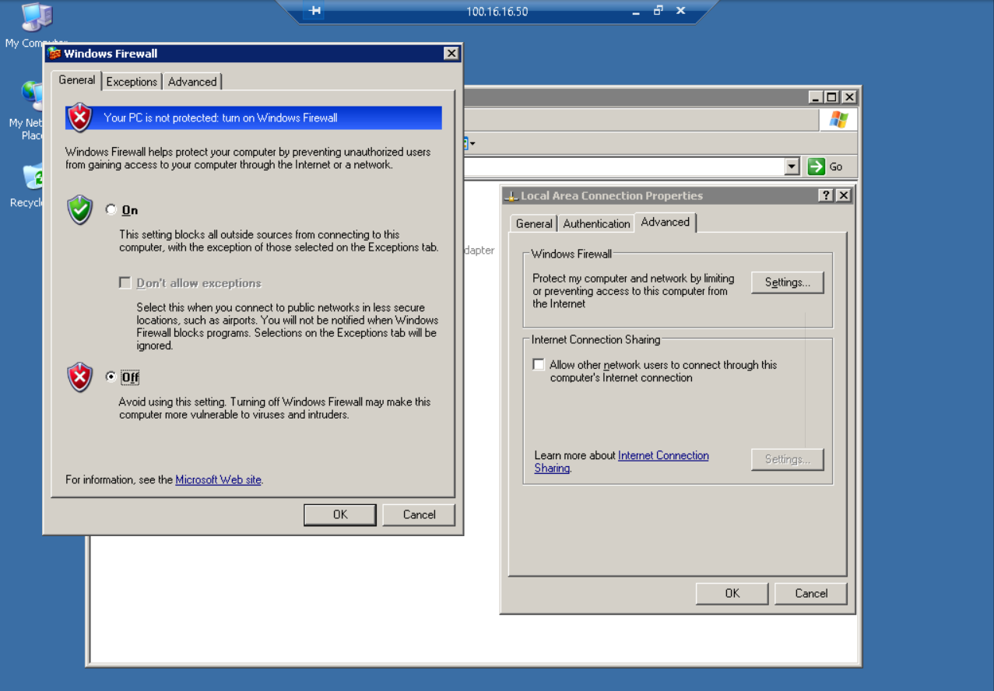

Restore the Command Prompt window, then execute netsh firewall set service type = remotedesktop mode = enable to permit traffic for the Remote Desktop service to pass through the firewall

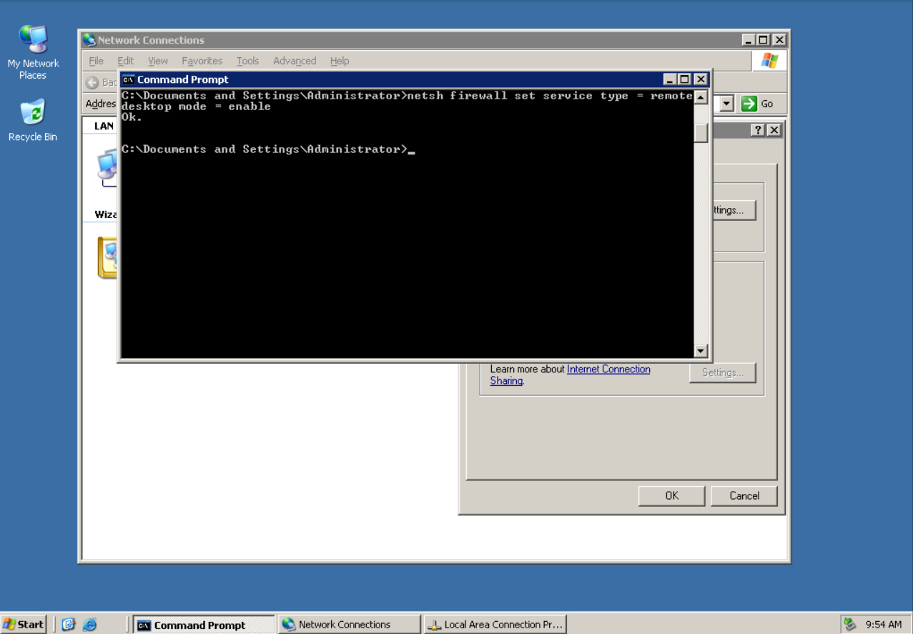

Minimize the remote TargetVulnerable01 connection to return to the vWorkstation, then launch a Command Prompt window

At the command prompt, execute ping 100.16.16.50 -t to initiate a continuous (-t) ping of the TargetVulnerable01 machine

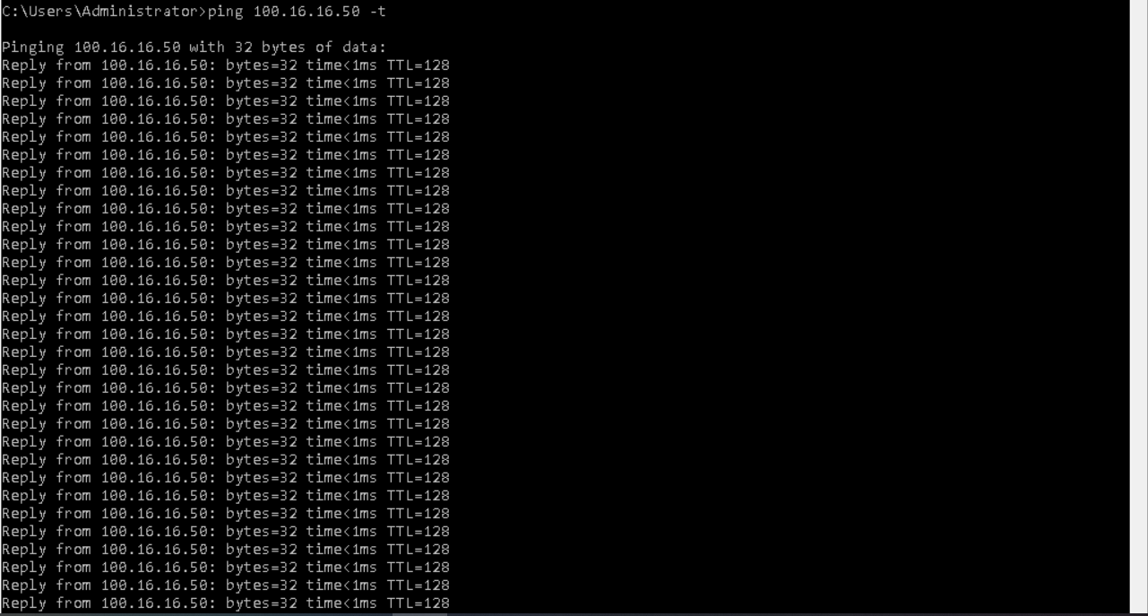

Restore the remote TargetVulnerable01 connection, then execute netsh firewall set icmpsetting 8 enable in the Command Prompt window to permit ICMP (ping) traffic to pass through the firewall

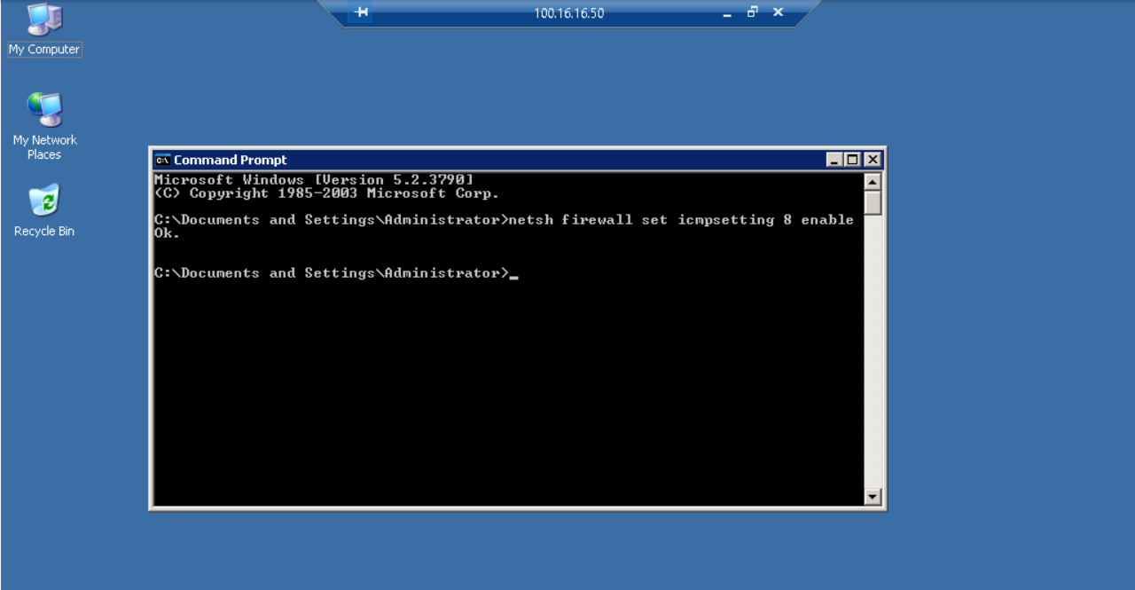

At the command prompt, execute netsh firewall set portopening tcp 445 smb disable to disable TCP traffic over port 445

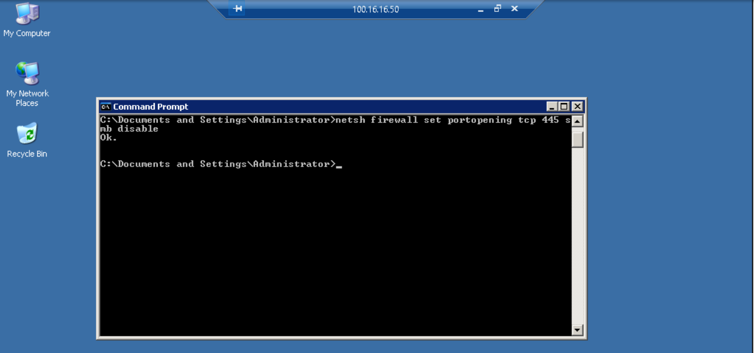

At the command prompt, execute netsh firewall set portopening udp 138 datagram disable to disable UDP traffic over port 138

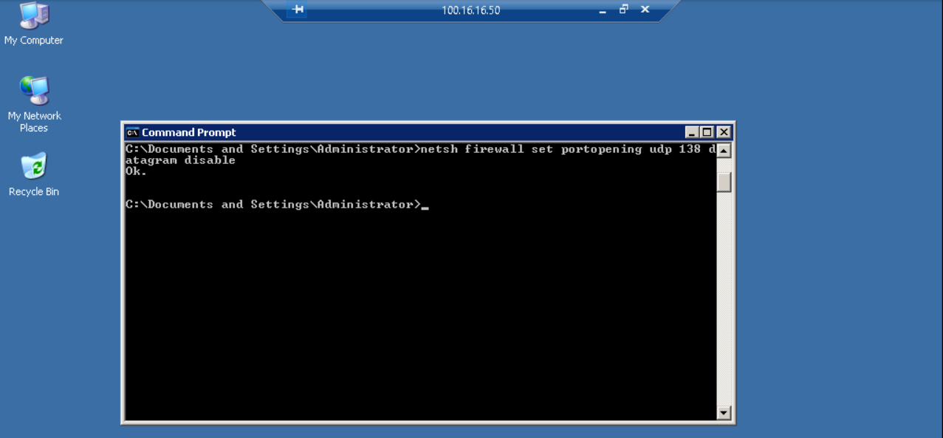

At the command prompt, execute netsh firewall set portopening udp 445 smbUDP disable to disable UDP traffic over port 445.

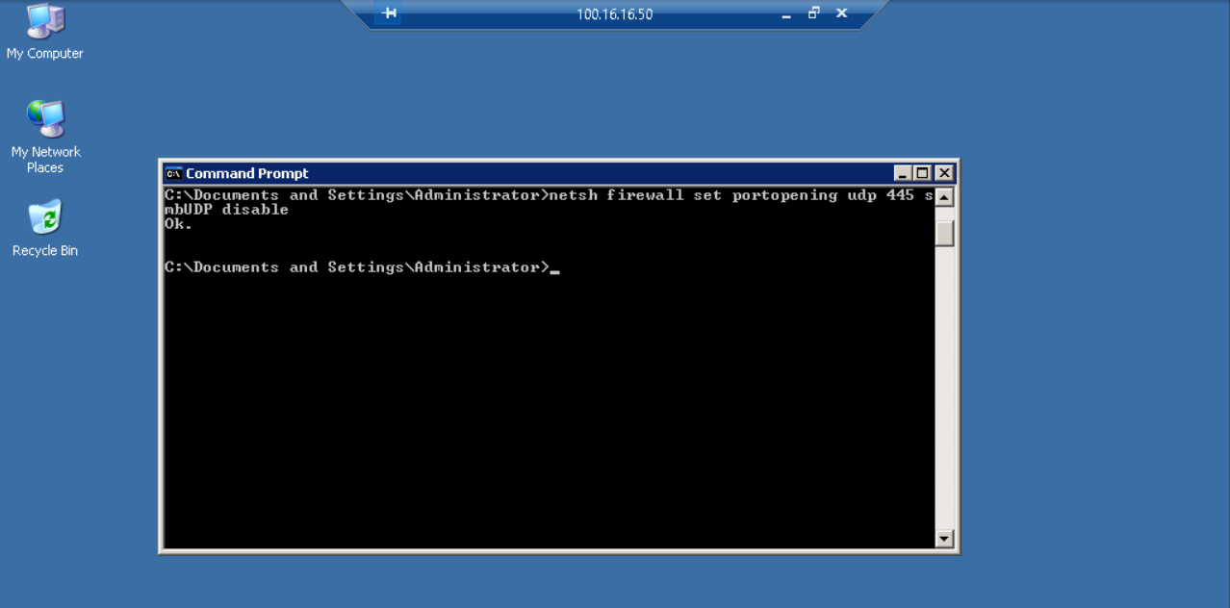

At the command prompt, execute netsh firewall set portopening udp 137 netbios disable to disable UDP traffic over port 137

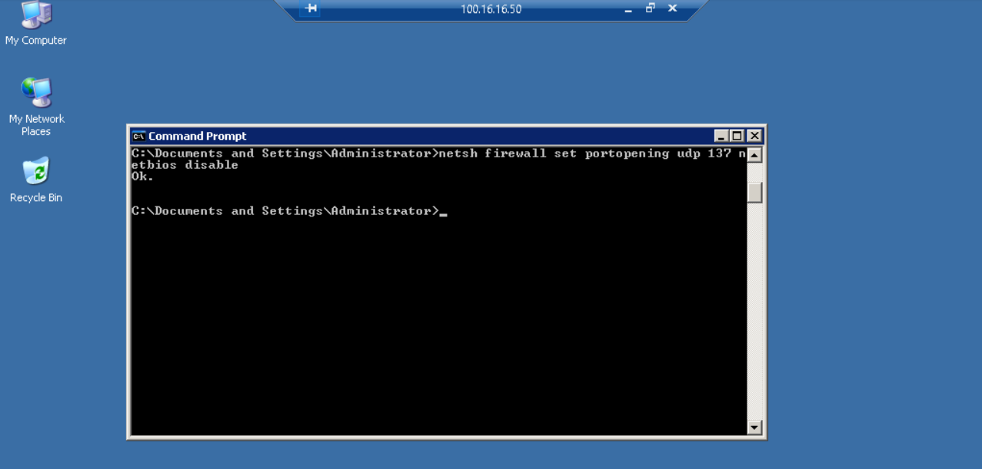

At the command prompt, execute netsh firewall set portopening udp 135 dcom-udp disable to disable UDP traffic over port 135

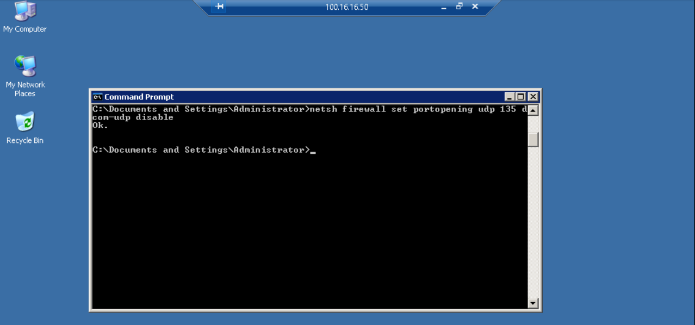

At the command prompt, execute netsh firewall set portopening tcp 135 dcom-tcp disable to

disable TCP traffic over port 135

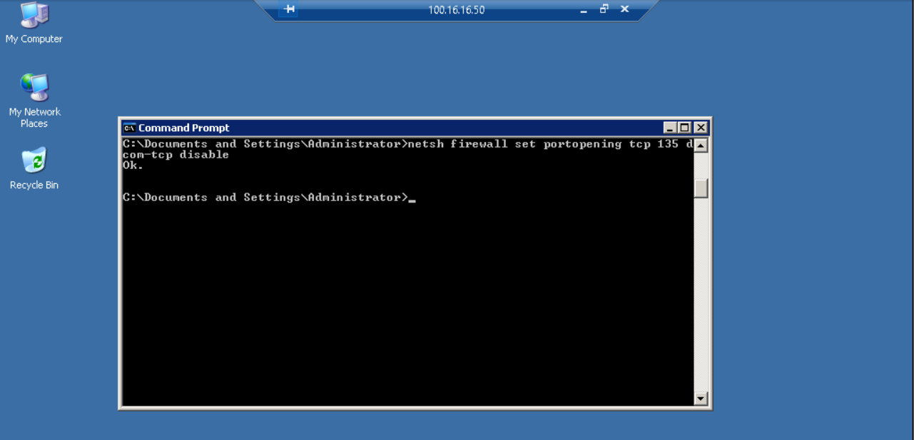

With the firewall rules addressed, you can disable the ICMP traffic. Once this rule is enforced, the ping request that is running on the vWorkstation will time out

At the command prompt, execute netsh firewall set icmpsetting 8 disable to disable ICMP (ping) traffic

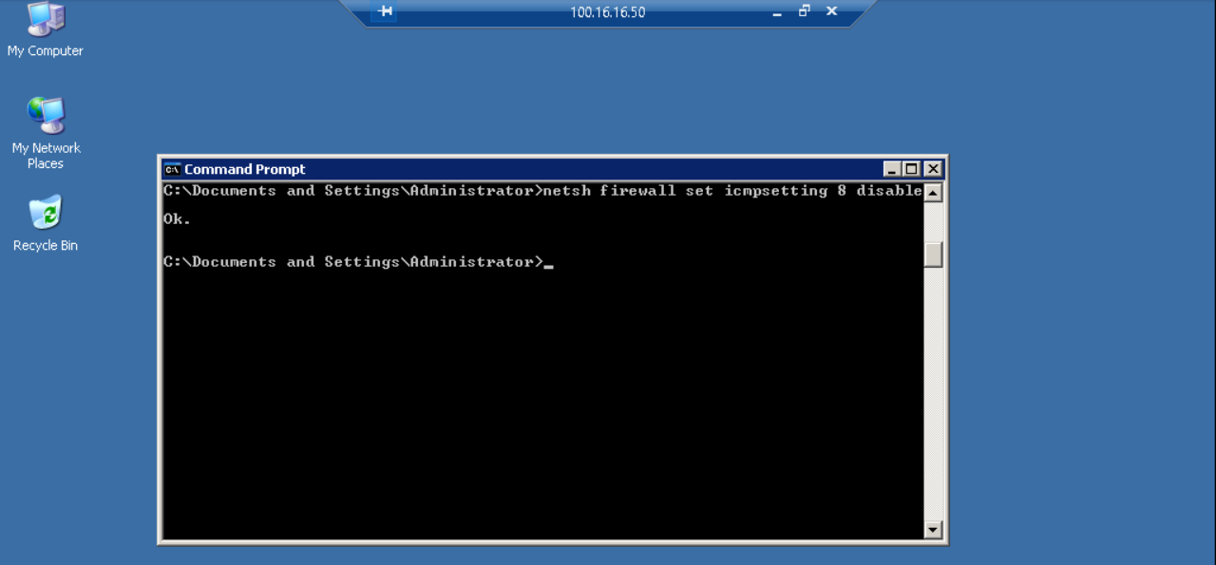

In the Command Prompt window, press Ctrl+C to stop the ping request

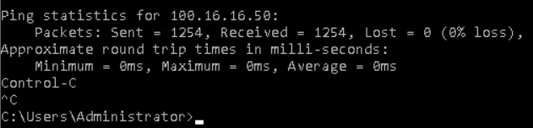

In the Windows Firewall dialog box, click the Advanced tab, then click the Security Logging Settings button to open the Log Settings dialog box

In the Log Settings dialog box, select the Log dropped packets and Log successful connections checkboxes, then click OK to save the new settings and close the Log Settings window

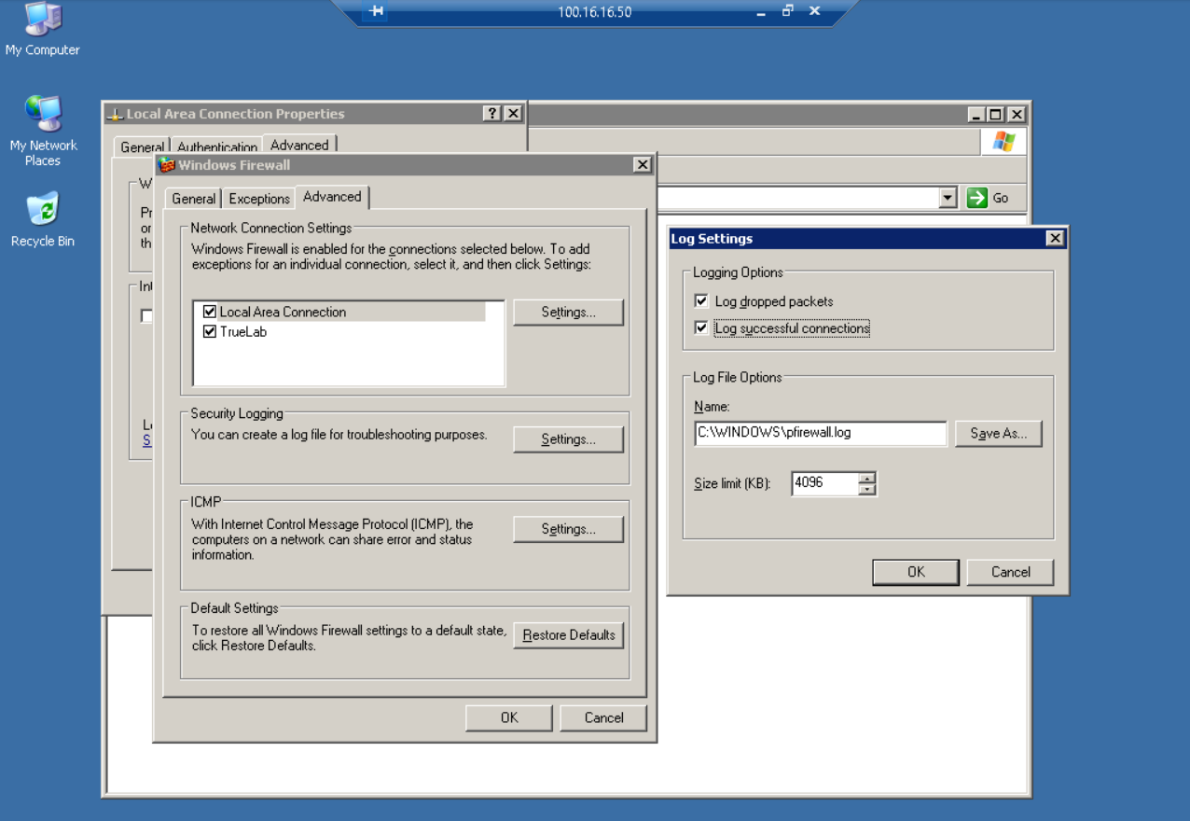

In the Windows Firewall dialog box, click the General tab, then click the On radio button and click OK to activate Windows Firewall abd close the Windows Firewall dialog box

At the command prompt, execute the Nmap command to re-run the Nmap operating system detection scan on TargetVulnerable01

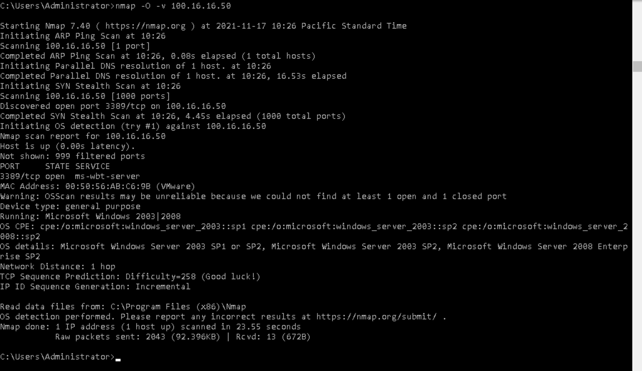

Part 4: Reduce the Attack Surface on the Windows 2008 Server

At the command prompt, execute hostname to display the host name of the machine

Make a note of the host name. In the next steps, you will use that host name in different commands

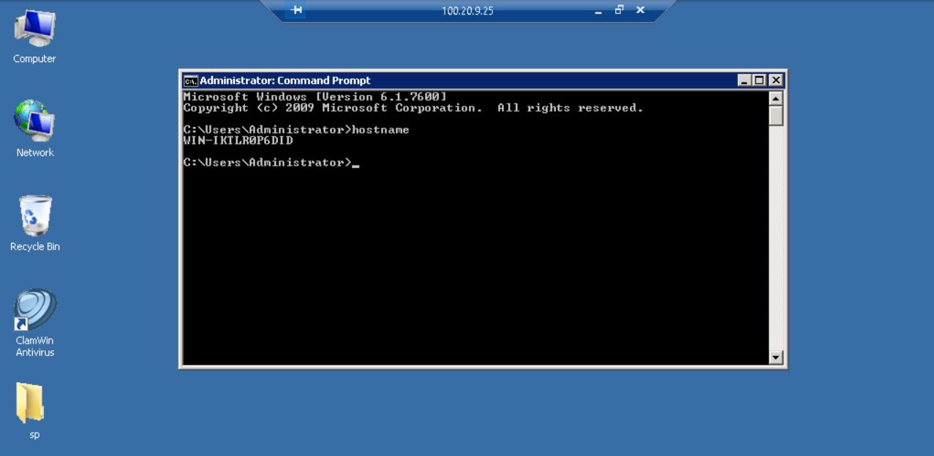

At the command prompt, execute netsh -r hostname advfirewall show allprofiles, replacing hostname with the host name displayed in Step 2, to display the firewall profiles

Note: There are three firewall profiles as shown in the following figure taken from the Microsoft Technet article at https://technet.microsoft.com/en-us/library/cc731634(v=ws.11).aspx

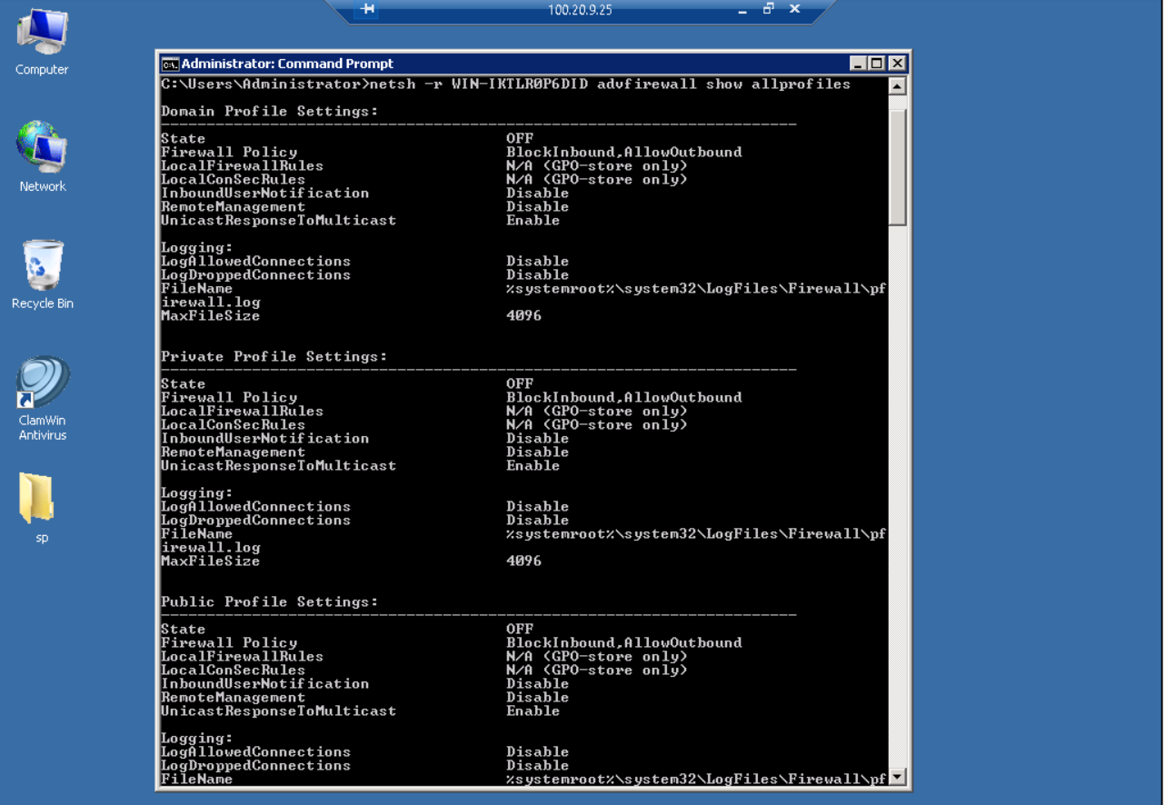

At the command prompt, execute netsh advfirewall firewall show rule name=all > rules.txt to copy all of the existing firewall rules into a text file

The command is executed at the C:\Users\Administrator directory, and will generate the rules.txt file in the Administrator directory

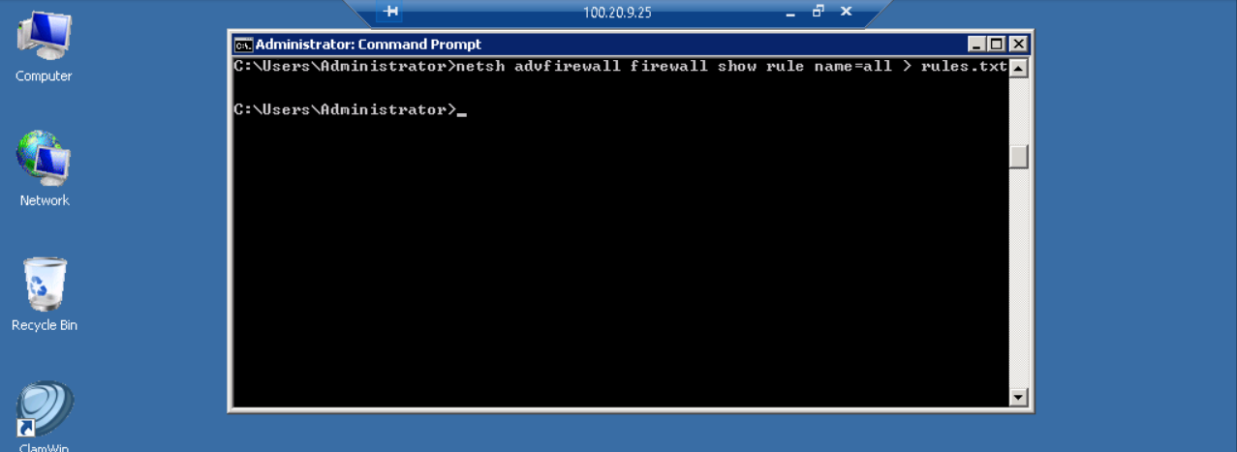

From the TargetWindows04 taskbar, launch the File Explorer, then navigate to the rules.txt file and open it

In the rules.txt file, locate the Remote Desktop rule in the list of rules

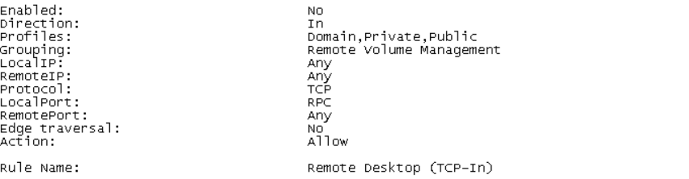

At the command prompt, execute netsh advfirewall firewall add rule name="All ICMP V4" dir=in action=allow protocol=icmpv4 to create a new rule to allow all ICMP traffic

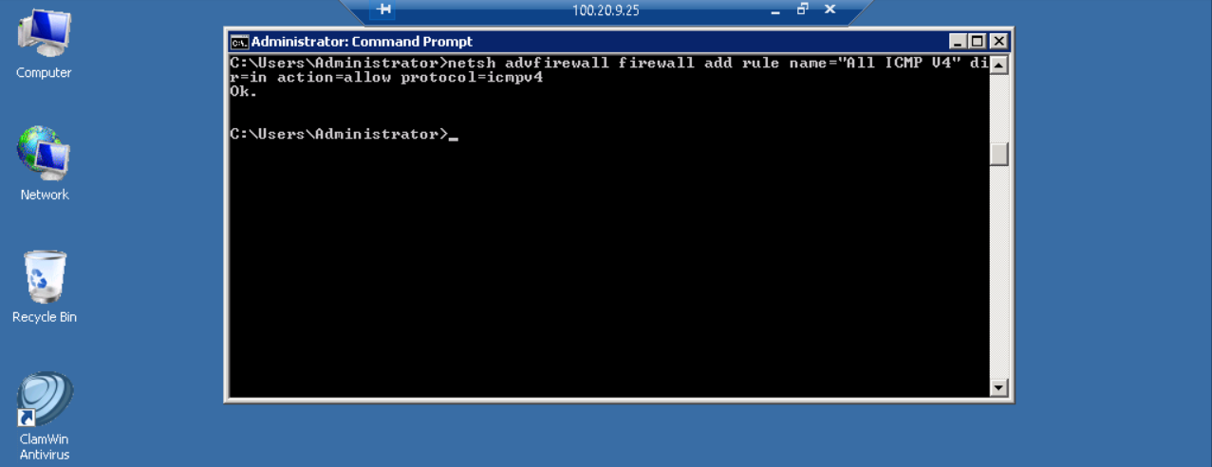

Minimize the remote TargetWindows04 connection to return to the vWorkstation

In the Command Prompt window, execute ping 100.20.9.25 -t to initiate a continuous (-t) ping request on the TargetWindows04 machine

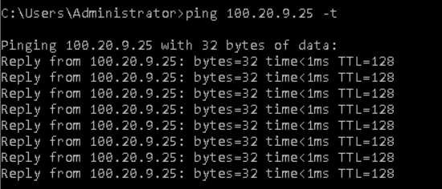

Restore the remote TargetWindows04 connection

At the command prompt, execute netsh advfirewall set allprofiles state on to set all firewall profiles to on

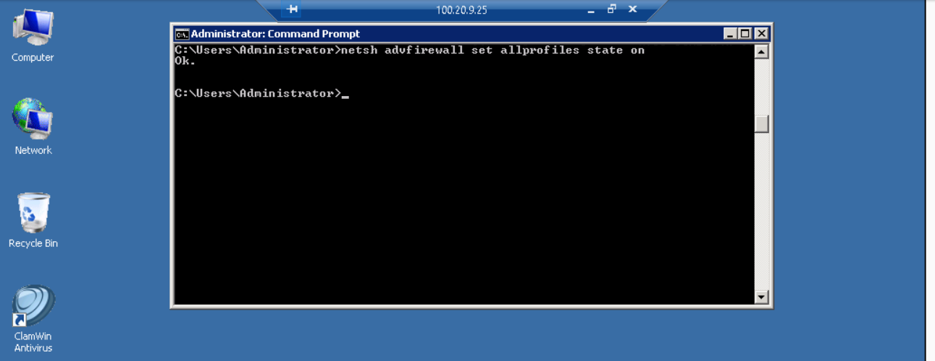

At the command prompt, execute netsh -r hostname advfirewall show allprofiles, replacing hostname with the host name displayed in Step 2, to show the state for all firewall profiles

All profiles are now set to on. With the firewall rules addressed, you can disable the ICMP traffic. Once this rule is enforced, the ping request that is running on the vWorkstation will time out

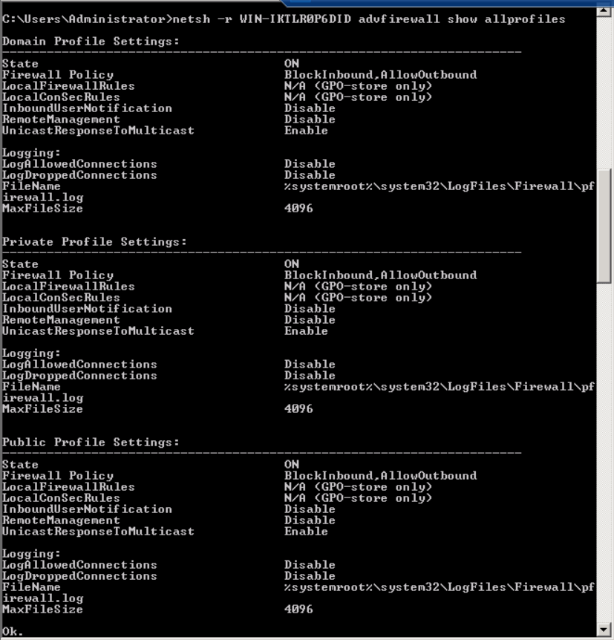

At the command prompt, execute netsh advfirewall firewall add rule name="All ICMP V4" dir=in action=block protocol=icmpv4 to disable ICMP (ping) traffic

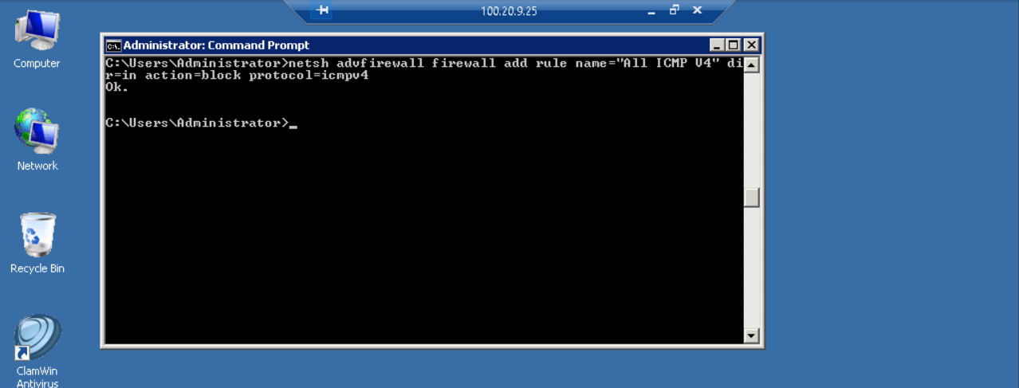

Minimize the remote TargetWindows04 connection to return to the vWorkstation and verify that the ping request timed out

Timed out ping of TargetWindows04

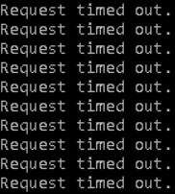

In the Command Prompt window, press Ctrl+C to stop the ping request

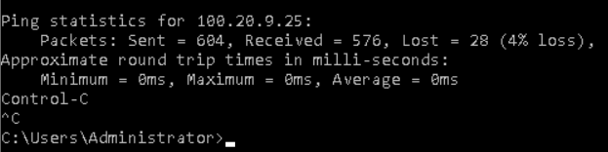

At the command prompt, execute the Nmap command to re-run the Nmap operating system detection scan on TargetWindows04

